# Complementarity of PXRD and ssNMR in structure solution of meloxicam multicomponent crystals

## P. Nowak1,2, A. Jeziorna1, M. Oszajca3, P. Paluch1, M. K. Dudek1

### 1Center of Molecular and Macromolecular Studies PAS, Sienkiewicza 112,90-363 Łódź, 2BioMedChem Doctoral School of University of Lodz and Lodz Institutes of PAS, Matejki 21/23, 90-237 Łódź, 3Faculty of Chemistry, Jagiellonian University in Kraków, Gronostajowa 2, 30-387 Kraków

### przemyslaw.nowak@edu.uni.lodz.pl

Meloxicam is an anti-inflammatory drug used for the bone and joint pain treatment and is found to have 4 polymorphic forms, but only the first one is easy to crystallize [1]. Formation of the multicomponent crystals of meloxicam with easily-sublimating coformers, like pyrazine or imidazole, is a crucial part of a new way of crystallization difficult to obtain (elusive) polymorphs of meloxicam. However, to fully understand this process, as well as to be able to rationally design such binary forms in the future, unveiling the crystal structures of these systems is required. In the case of the studied systems Liquid Assisted Grinding (LAG) or heating were chosen to obtain multicomponent crystals of meloxicam due to the low solubility of the API in the majority of organic solvents. Unfortunately, both methods lead to the formation of powdered crystal phase, and several recrystallization attempts to obtain monocrystals with a solvent-based technique failed. In this work, we investigate the crystal structures of 1:0.5 meloxicam:pyrazine, and 1:1 and 1:2 meloxicam:imidazole binaries with PXRD and ssNMR as a complementary method. In particular, the registered diffractograms were used to index the unit cells and molecular dynamics (MD) calculations were performed to solve the structures, while solid-state NMR measurements at two different magnetic field strengths were used to unambiguously establish the protonation state in the aforementioned structures. This was done basing on the quadrupolar product values (PQ) extracted from the 1H-14N T-HMQC experiments, as well as the detailed 1H signal assignment, possible due to performing the experiments at 1 GHz magnetic field (see Fig. 1 for 1H-1H correlation spectrum). As a result, it was determined that in meloxicam:pyrazine cocrystal the API is present in a very unusual tautomeric form (Fig. 1), unprecedented before in any of meloxicam crystalline forms. For the two crystals of meloxicam with imidazole it was discovered that 1:1 form is a salt, while 1:2 from is a mixed salt-cocrystal, with one protonated imidazole molecule, and the other being in its natural form. This enabled the addition of the hydrogen atoms at the appropriate sites in the crystals, leading to a successful Rietveld refinement. Thus, combining solid-state NMR spectroscopy with the powder X-ray diffraction methods allowed for a full description of the three new structures of meloxicam multicomponent crystals.

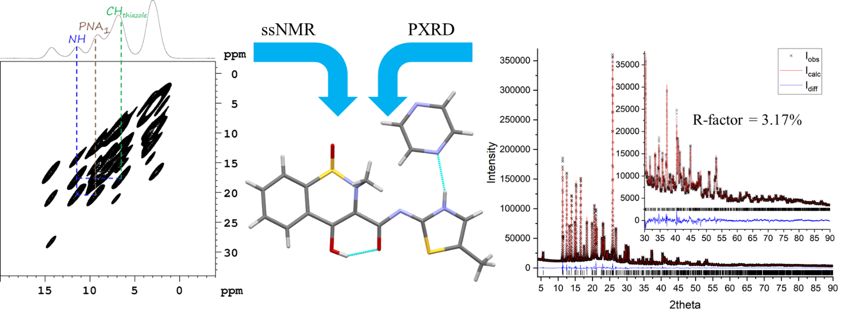

**Figure 1**. 1H-1H DQ-SQ Back-to-Back spectrum registered at 1 GHz magnet (left) and comparison of the registered diffractogram with the calculated after Rietveld refinement(right) for meloxicam-pyrazine cocrystal (structure in the middle).

[1] Jeziorna, A., Paluch, P., Zając, J., Dolot, R., Dudek, M. K., (2023) Crystal Growth & Design, 23 (8), 5998-6010

This work was possible due to the financial support of the Polish National Science Centre under Sonata BIS grant No.2022/46/E/ST4/0039. The NMR studies has been supported by PANACEA, which received funding from the European Union’s Horizon 2020 research and innovation programme under Grant Agreement No 101008500