# Experimental Charge Density Investigations: Data and Model Quality

## Regine Herbst-Irmer1

### 1Institut für Anorganische Chemie, Georg-August-Universität Göttingen, Tammannstraße 4, D-37077 Göttingen, Germany

### rherbst@chemie.uni-goettingen.de

Investigations into charge density focus on deviations from spherical valence density to describe the bonding situation within a given structure (see Fig. 1). This lecture will focus on the Hansen & Coppens multipole model [1] to describe this asphericity. Because these deviations are typically small compared to the electron density of the atomic cores, achieving the highest possible quality of the data and the most resilient model are essential for meaningful experimental charge-density analysis [2].

High data quality in charge-density studies depends on more than just high resolution, high *I*/σ(*I*) values, low merging *R* values and high multiplicity. In particular, the quality of the innermost reflections is crucial for mapping the density distribution of the outermost, valence electrons. Over recent decades, significant advancements in X-ray sources and detectors have transformed data acquisition. In terms of detectors, technology has progressed from point detectors to CCD and nowadays energy-discriminating pixel detectors, which greatly reduced the data collection time and foster spectral purity. The development in X-ray sources, from sealed tubes to microsources, rotating anodes, MetalJet to synchrotrons radiation, have steadily increased beam intensity [3]. However, those advancements sometimes introduce unexpected contaminations leading to less monochromaticity of the beam [4]. Additionally, effects like thermal diffuse scattering lead to systematic errors in the electron density. Both should be minimised during data collection or at least corrected in data processing.

During refinement the best possible model should be found without overfitting the data. For instance, anharmonic motion may result in shashlik-like residual density patterns. While this effect can be modelled using third- or fourth-order Gram–Charlier coefficients, doing so introduces 10 or even 25 additional parameters per atom. Cross-validation can help to detect if the [refinement](https://dictionary.iucr.org/Refinement) of additional parameters yields a real improvement in the model or simply overfits the given data. However, also the physical reliability of the derived model must be thoroughly analysed.

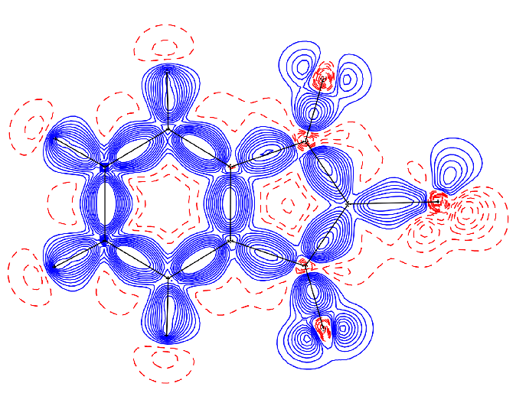

###### Figure 1. Deformation density map of sulfur ylide after a multipole refinement [4]. Contours shown at ± {0.05 0.10 0.15 0.20 0.25 0.30 0.35 0.40 0.45 0.50 0.55} eÅ−3 with positive values in blue and negative values in red

#### [1] Hansen, N. K. & Coppens, P. (1978). *Acta Cryst.* A**34**, 909.

#### [2] Herbst-Irmer, R. & Stalke, D. (2017). *Acta Cryst.* B**73**, 531.

#### [3] Ruth, P. N., Graw, N., Ernemann, T., Herbst-Irmer, R. & Stalke, D. (2023). *J. Appl. Cryst.* **56,** 1322.

#### [4] Graw, N., Ruth, P. N., Ernemann, T., Herbst-Irmer, R. & Stalke, D. (2023). *J. Appl. Cryst.* **56,** 1315.