# Modeling the protein electrostatic potential Fourier maps across resolutions

## M. Kulik1, P. M. Dominiak1

### 1University of Warsaw, Faculty of Chemistry, Biological and Chemical Research Centre, Zwirki i Wigury 101, 02-089 Warsaw, Poland

### m.kulik@uw.edu.pl

Typically, lower-resolution experimental maps from single-particle cryogenic electron microscopy or 3D electron diffraction contain less detail compared to higher-resolution maps. However, charged moieties tend to be easier to recognize at lower resolutions. To investigate this issue, we studied how truncating high-resolution data affects Fourier images of protein crystal electrostatic potential. To do this, we used both the common independent atom model (IAM) and the more precise transferable aspherical atom model (TAAM), combined with the Multipolar Atom Types from Theory and Statistical clustering (MATTS) data bank [1,2] (successor of UBDB). The detailed procedure was described in [3]. MATTS data bank gathers all aspherical atom types necessary to model the electron density of proteins and other macromolecules. One can also model the electrostatic potential of macromolecules, not only at their surface, but within their entire volume. It is a more accurate approach than using simple point charge models but also less computationally-demanding than the conventional quantum mechanics methods.

Our results indicate that the theoretical electrostatic potential maps of proteins calculated with TAAM and IAM approach at resolutions close to 4 Å, shown in the upper panel in Figure 1, are strikingly different at the charged residues positions. In particular, the TAAM electrostatic potential of Asp residues presented at 2 sigma contour has literally vanished from the map due to the negative scattering of charged carboxylate oxygen atoms. This effect is much less pronounced in the IAM map. A reverse pattern is observed for the positively charged Lys residues. At 4 Å resolution, the TAAM map contour covers a larger volume compared to IAM, while the positive electrostatic potential of the ammonium group is entirely absent in the IAM map. If we compare those electrostatic potential maps with the electron density maps generated with TAAM and IAM, we would notice a remarkable similarity not only between both electron density maps but also between those electron density maps and the electrostatic potential maps modeled with IAM. It stems from the fact that both the X-ray diffraction and the IAM are almost insensitive to a change of the partial charge that is frequently observed in protein functional groups. Moreover, if we truncate also the low-resolution reflections in the procedure for generating the electrostatic potential maps at 4 Å resolution, as presented in the lower panel of Figure 1, it is clear that the information about the sensitivity to charged moieties is hidden in the lowest resolution data range. This result underlines the importance of careful modeling of the low-resolution signal in single-particle cryogenic electron microscopy and 3D electron diffraction.

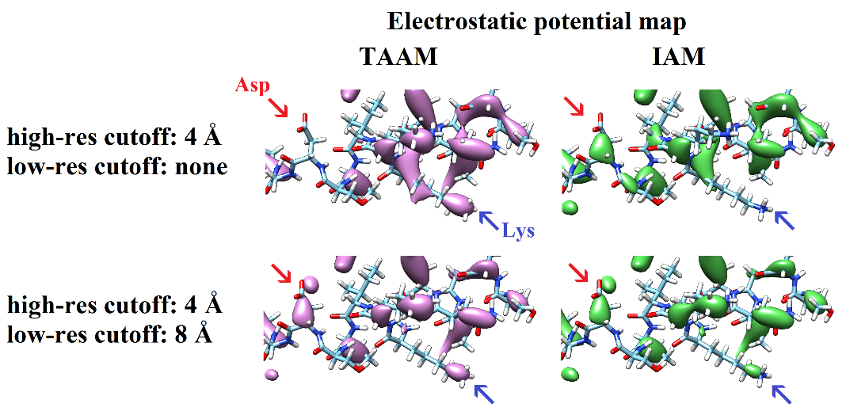

###### **Figure 1**. 3D Fourier electrostatic potential maps calculated using TAAM/IAM with thermal smearing effects and the data resolution ranges ∞ – 4 Å and 8 – 4 Å for lysozyme residues. The maps are shown at 2 sigma contour.

#### [1] Jha, K. K., Gruza, B., Sypko, A., Kumar, P., Chodkiewicz, M. L. & Dominiak, P. M. (2022). *JCIM*, **62**(16), 3752–3765.

#### [2] Rybicka, P. M., Kulik, M., Chodkiewicz, M. L. & Dominiak, P. M. (2022). *JCIM*, **62**(16), 3766–3783.

#### [3] Kulik, M., Chodkiewicz, M. L. & Dominiak, P. M. (2022). *Acta Cryst. D*, **78**(8), 1010–1020.

The authors acknowledge NCN UMO-2017/27/B/ST4/02721 grant.