Deep Learning for smart sample alignment

A.V. Luebben¹, J. Luebben¹

¹Bruker AXS, Östliche Rheinbrückenstraße 49, 76187 Karlsruhe

Anna.Luebben@Bruker.com
Development of new Deep Learning techniques have impacted a wide range of research areas [1]. One area where deep neural networks have proven powerful is the processing and interpretation of images [2]. We built on top of these methods to develop a novel technique to streamline the process of aligning crystal samples in the centre of a single crystal X-ray diffractometer.
The neural network is designed to mimic the decision-making process of an experienced crystallographer, going through the procedure of finding the most promising position for X-ray exposition, providing valuable feedback to novices and expert users alike. The method utilizes a two-stage model built on top of the ResNet family of convolutional neuronal networks and is trained on several millions of reference images [3]. The resulting model is lightweight enough to run on any modern desktop or laptop PC, providing seamless real-time feedback to users of Bruker’s APEX and PROTEUM software suites (Figure 1). Focus was placed on flexibility and extensibility of the model to facilitate adaptation to more specialized applications without requiring costly and time-consuming retraining.
In our presentation we will describe the process in more detail and discuss a few challenging samples highlighting the impressive power of the approach.

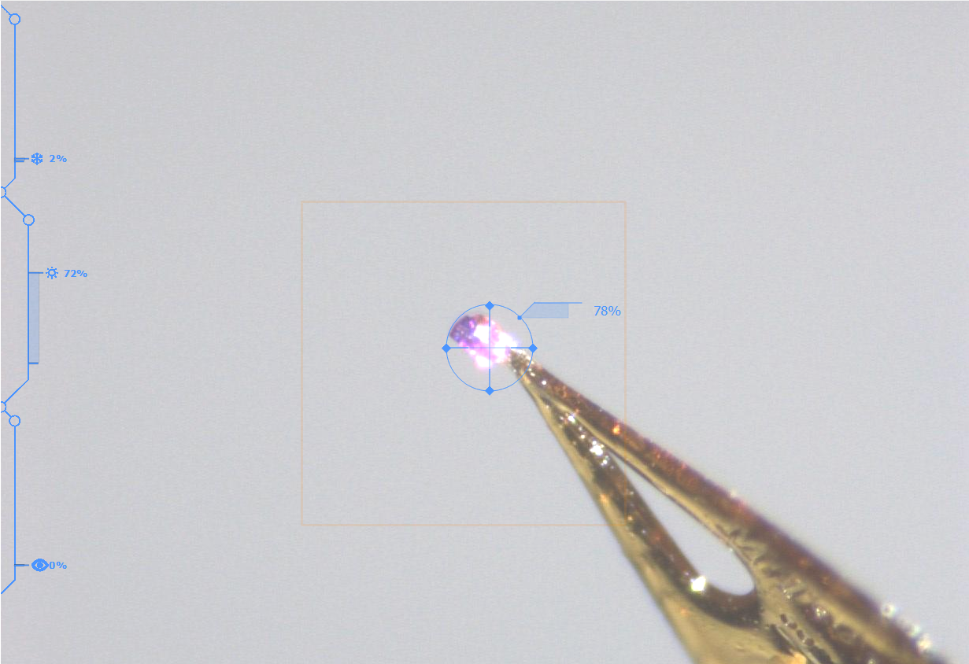

Figure 1. Direct visual feedback during Deep learning assisted crystal centering.

[1] Alzubaidi, L., Zhang, J., Humaidi, A.J. et al. (2021). J Big Data. 8, 53.

[2] Ito S, Ueno G, Yamamoto M. (2019). J Synchrotron Radiat. 26(Pt 4), 1361.

[3] Kaiming He, Xiangyu Zhang, Shaoqing Ren, Jian Sun (2015). Deep Residual Learning for Image Recognition. arXiv:1512.03385.

