# Neutron diffraction observed in the Earth's gravity field

## I. Sosnowska

### Faculty of Physics, University of Warsaw, Pasteur 5, 02-093 Warsaw, Poland

### izabela@fuwedu.pl

The presented experiment shows two effects simultaneously: neutron diffraction (a wave property of neutrons) and the gravitational phenomenon together.  The dualism of matter is observed when the diffracted neutron in a crystal contributes to the Debye-Scherrer ring (part of the ring can be seen in the photo). After scattering in a crystal neutron, the massive particle ( m=1.67492749804(95)×10−27 [kg](https://en.wikipedia.org/wiki/Kilogram)) falls into the gravity field of the Earth (like Newton's apple). Neutrons have no electric charge—their trajectory changes when they interact with atomic nuclei. Therefore, in the experiment, we observe two interactions of neutrons with the atomic nuclei of the opal (ordered silica-water system [1-3]) and with the gravitational field.

The SANS experiment was performed on the rearranged diffractometer D11 at ILL using long wavelength slow neutrons (λ= 17.9 Ǻ) and a long flight path after scattering longer than usually used at D11 [2,5].  With one's own eyes, one can see the dual, a neutron wave (diffraction), and the neutron as a massive particle in the Earth's gravity field**.**. It is difficult to imagine that such complicated effects could be seen with one's own eyes. Similarly, for gamma quanta (the Mössbauer effect), it was shown that the gamma quanta feel the gravity of the Earth. [6].

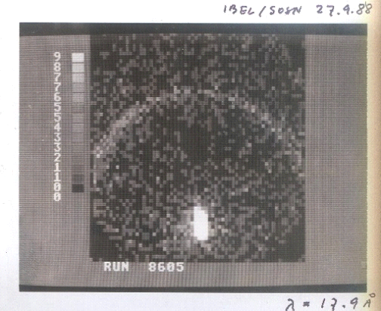

###### **Figure**. Photo of a two-dimensional neutron detector showing neutron diffraction on opal. A part of the Debye-Scherrer ring of neutrons diffracted on the (111) planes of opal [4-5] (lattice constant a, a = 206 nm). Neutron wavelength was λ=17.9Ǻ. Not diffracted neutrons are registered as a white spot [3]. The primary neutron beam was blocked with Cd (black area in the center of the detector). The white spot non-diffracted monochromatic neutron beam also falls as the Debye-Scherer ring in the gravitation field. The Debye-Scherrer ring (in the photo) is shifted from the detector center (the gravitational field effect of the Earth).).

#### **[1**] Sanders J.V, .(1968) .*Acta CrystA***24**, 427.

#### [2] Sosnowska & Ibel, K., (1988). unpublished,

#### [3] Sosnowska, I., Buchenau, U., Reichenauer G, Graetsch H.,Ibel,K .&.Frick, B, (1997). *Physica* B, **234–236**, 455

#### [4] Sosnowska, I. & M.J. Shiojiri, , (1999), *Electron Microscopy*, **48**, 681

#### [5] Mildner D.F.R & Cubitt, R.(2012) , *J. Appl. Cryst*., **45**, 124.

#### [6] Pound R.V& Repka V., (1959), *Physical Review Letters*, **3**, 439.