# Hands-on learning activities for chemical crystallography students derived from data and tools provided by the Cambridge Crystallographic Data Centre

## Diane A. Dickie1

### 1Department of Chemistry, University of Virginia, Charlottesville, VA, USA

### dad8v@virginia.edu

Small molecule X-ray diffraction studies are found in all types of synthetic chemistry research. Unfortunately, many chemists have not received extensive training in crystallography. They may collaborate with a crystallographer for their own research, but rely on their own knowledge when, for example, evaluating manuscripts as a peer-reviewer. This mismatch of skills and knowledge has led to numerous examples of low-quality structures being published in chemistry journals and subsequently archived in databases such as the Cambridge Structural Database (CSD). To improve the quality of crystallographic work in the future, non-experts need to be taught what tools are available to help them evaluate the structures that they encounter as throughout their careers.

This presentation describes activities designed to introduce advanced undergraduate and beginning graduate students to the vast resources of the CSD and other databases, and how those resources can help them identify and often correct common mistakes in the solution and refinement of small-molecule structures. Because most deposited structures now contain embedded reflection data, students are able to attempt their own refinements of previously-published data. Empowering students to select molecules of personal interest from the database to use for practice piques their interest much more than when they are assigned molecules by an instructor. The database also allows them to encounter many more types of structures and crystallographic challenges (disorder, twinning, etc.) than could be generated from in-house structures. Finally, the database provides examples of both excellent work and extremely questionable work, giving them the opportunity to compare and contrast their skills with those of the original authors.

One example of this approach has been to use the CSD’s ConQuest search tool to identify structures with unusually high R1 values, retrieve the data via WebCSD, and then attempt to re-refine the structure [1]. Ten-fold improvements in R1 values have been obtained on more than one occasion by correcting errors including missed molecules in Z’ > 1 structures, inaccurate direct methods solutions, and misidentified unit cell parameters. These and other examples will be discussed, all of which rely on CSD tools and data.

.

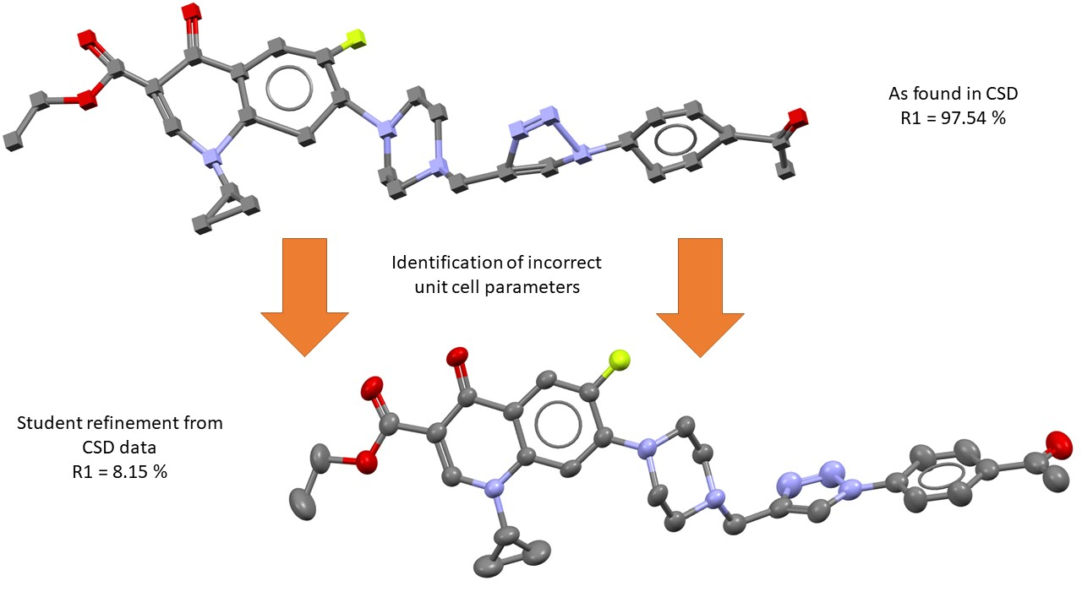

###### **Figure 1**. An example of a poorly-refined structure identified using ConQuest and then refined by chemical crystallography students.

#### [1] Meng, A. Q., Diment, L. A., Abdi, A., Hubbs, V. J., Jeffreys, E. A., O’Dell, M., Ou, X., Park, K. A., Quillin, B. T. & Dickie, D. A. (2024). *Cryst. Growth Des.,* **24**, 4690.

The students of CHEM 5380 have been the inspiration for and testers of the activities in this presentation.