Mechanistic insights into heme iron photoreduction: influence of temperature on redox and structural states

V. Pfanzagl¹

¹Institute of Biochemistry, Department of Natural Sciences and Sustainable Resources, BOKU University, Muthgasse 18, Vienna, Austria

vera.pfanzagl@boku.ac.at

X-ray crystallography is a key method for gaining atom-level insight into how molecules are coordinated within the active sites of metalloproteins. By analyzing ligand binding, interatomic distances, and the spatial arrangement of catalytic amino acids, enzymologists aim to uncover the electronic mechanisms underlying enzymatic reactions. As such, accurately determining the redox state and conformation of the metal cofactor is critically important. However, because metal cofactors are redox-active, they are particularly prone to photoreduction caused by X-ray irradiation, which can compromise the reliability of structural data obtained using such methods. [1,2]. To date few heme enzyme systems has been investigated with respect to the structural changes arising from photoreduction, and even less have been subjected to different modes of data collection. It is clear that at cryo-temperature the heme environment, and in particular the water molecules and the hydrogen bonding network formed by them, will change upon reduction of the heme iron (as seen in Figure 1 C). However, the rise in serial crystallography techniques, such as serial synchrotron crystallography (SSX) and serial femtosecond crystallography (SFX), has re-introduced the notion of room temperature data collection.
Here, we provide a comprehensive analysis of the bacterial enzyme KpDyP from Klebsiella pneumoniae, focusing on photoreduction phenomena at both cryogenic and room temperatures using a range of experimental techniques. Our investigation includes data from (I) cryogenic single-crystal X-ray diffraction, (II) cryogenic serial crystallography, (III) room-temperature serial femtosecond crystallography (SFX), (IV) dose-dependent room-temperature serial synchrotron crystallography (SSX), and (V) time-resolved SFX combined with time-resolved X-ray emission spectroscopy (tr-XES). These experiments explore the ferric resting state and highly oxidized intermediates generated by in crystallo reaction with hydrogen peroxide. Additionally, we compare our findings with extensive structural data from the closely related DtpAa enzyme of Streptomyces lividans [3], revealing that structural similarity does not necessarily equate to identical photoreductive behaviour. Our results raise, and begin to address, a key question: to what extent is photoreduction at room temperature counteracted by oxidative forces, and which structural and biochemical factors govern this apparent “rescue” mechanism?
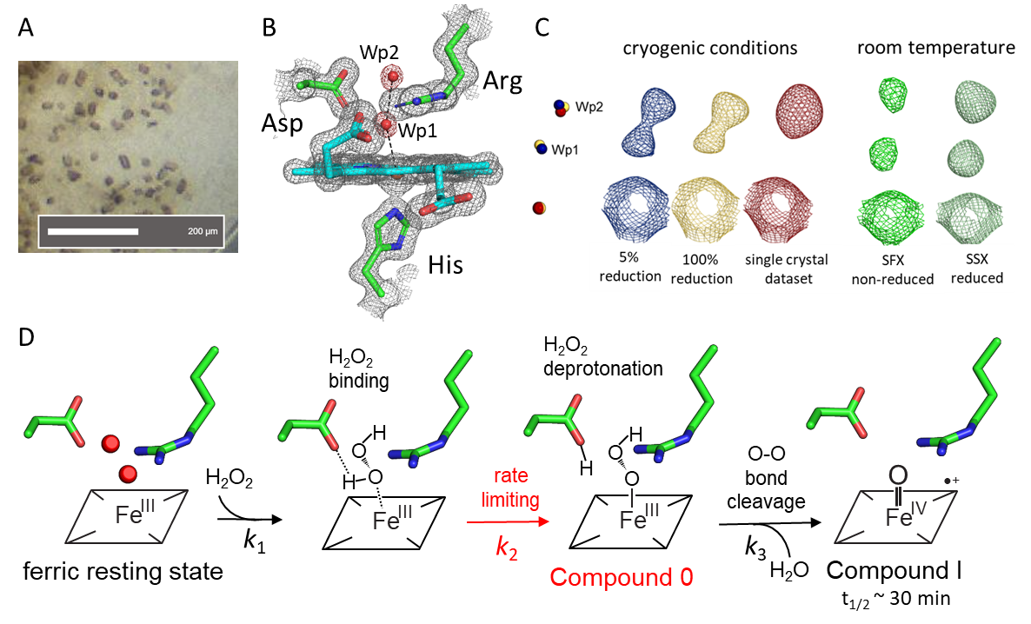

Figure 1: Overview of crystallographic data collected on B-Type KpDyP. A) Microcrystals of KpDyP in the ferric resting state; B) electron density for the Fe(III) resting state determined by SFX; C) electron density for the active site waters and the heme iron in a single crystal data set (red) or serial crystallography data sets at cryo or room temperature with the iron in reduced Fe(II) or non-reduced Fe(III) state; D) proposed reaction mechanism of Compound 0 and Compound I formation with H₂O₂.

[1] G. I. Berglund, G. H. Carlsson, A. T. Smith, H. Szöke, A. Henriksen, J. Hajdu, Nature 417 (2002), 463-468
[2] T. Beitlich, K. Kühnel, C. Schulze-Briese, R. L. Shoeman, I. Schlichting, J Synchrotron Radiat 14 (2007), 11-23
[3] V. Pfanzagl, K. Nys, M. Bellei, H. Michlits, G. Mlynek, G. Battistuzzi, K. Djinović-Carugo, S. Van Doorslaer, P.G. Furtmüller, C. Obinger, J. Biol Chem 293 (2018), 14823-14838
[4] A. Ebrahim, T. Moreno-Chicano, M. V. Appleby, A.K. Chaplin, J. H. Beale, D. A. Sherrell, H. M. E. Duyvesteyn, S. Owada, K. Tono, H. Sugimoto, R. W. Strange, J. A. R. Worrall, D. Axford, R. L. Owen, M. A. Hough, IUCrJ 6 (2019) 543-551.

