# Three new polymorphs of glyphosate under extreme conditions

## Chengdao Hu,1 Cameron J. G. Wilson,1 Nico Giordano,2 Nicholas P. Funnell,3 Christopher J. Ridley3, Simon Parsons1

### 1EaStCHEM School of Chemistry and Centre for Science at Extreme Conditions, The University of Edinburgh, King's Buildings, West Mains Road, Edinburgh EH9 3FJ, United Kingdom, 2Deutsches Elektronen-Synchrotron DESY, Notkestr. 85, 22607 Hamburg, Germany, 3ISIS Neutron and Muon Source, Rutherford Appleton Laboratory, Didcot, Oxfordshire OX11 0QX, United Kingdom

### Chengdao.Hu@ed.ac.uk

High pressure is a well-established tool for investigating polymorphism in molecular materials both at central facilities and in home laboratories. The phase behaviour of the herbicide glyphosate – *N*-(phosphonomethyl)glycine – has been investigated to identify its structural characteristics at high pressures. Single-crystal X-ray diffraction data were collected, both in-house on the Bruker AXS D8 Venture diffractometer incorporating an Incoatec Mo K*α* microsource [1] and on the extreme conditions beamline, P02.2, of PETRA III at the Deutsches Elektronen-Synchrotron (DESY) with additional powder neutron diffraction data collected on the PEARL instrument at ISIS.

Three new high-pressure phases have been identified between ambient conditions and 8.56 GPa under various experimental set-ups. Phase I (*P*21/*c*) of glyphosate has been observed up to a pressure of 5.18 GPa via X-ray diffraction studies on slow compression of a single crystal in a diamond anvil cell (Fig. 1a) [2]. Two more high-pressure phases (phase II, *P*21/*c*, and phase III, *P*21/*n*) were observed on rapid compression and in different pressure-transmitting media [3].

In DESY experiments, at the highest pressures measured, 8.56 GPa, glyphosate exists in a new triclinic phase IV (*P*-1), and its packing scheme is shown in Fig 1b. The transition to this phase was observed to begin at 6.23 GPa with crystals consisting of domains of a mixture of phase II and IV. From 7.30 GPa onwards, the crystal appears to be phase IV only, with the data quality deteriorating notably at 8.56 GPa. The molecular backbone of glyphosate becomes more hunched with the increase of pressure, and the conformational changes of glyphosate are primarily reflected in the carbonyl group of the molecule. The structure becomes less responsive towards compression beyond 7.30 GPa with minimal changes observed up to 8.56 GPa. Combing the X-ray diffraction structural data for phase IV with the neutron diffraction data, some of the previously unidentified residual peaks in the powder studies are successfully solved, and the introduction of phase IV into the refinements considerably improved the fits for high-pressure neutron data patterns.

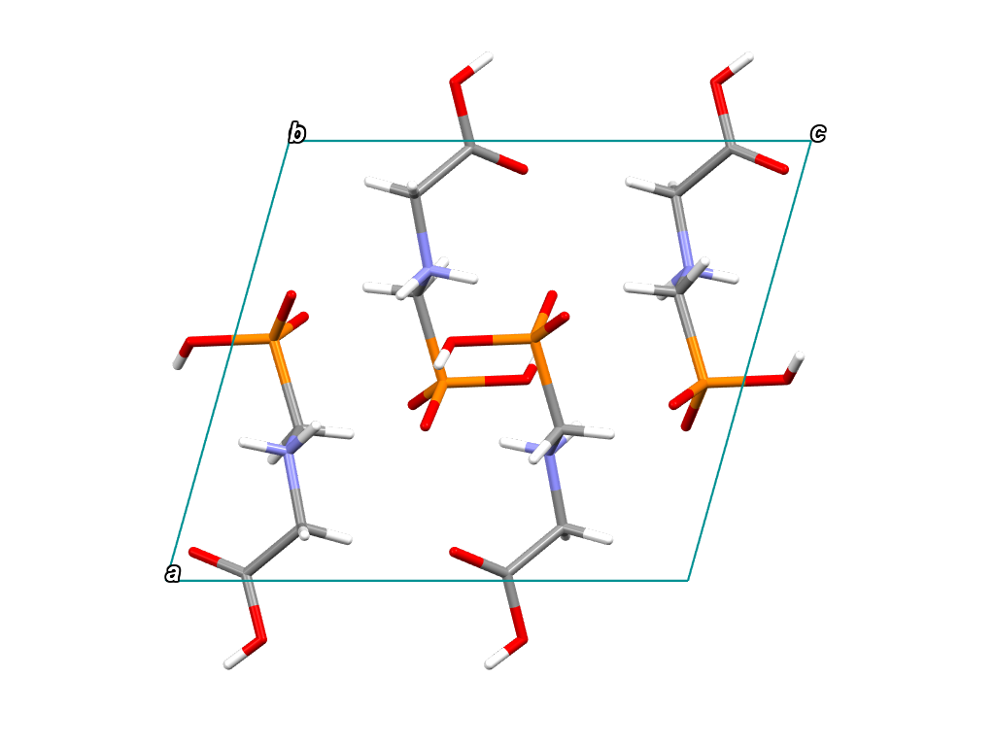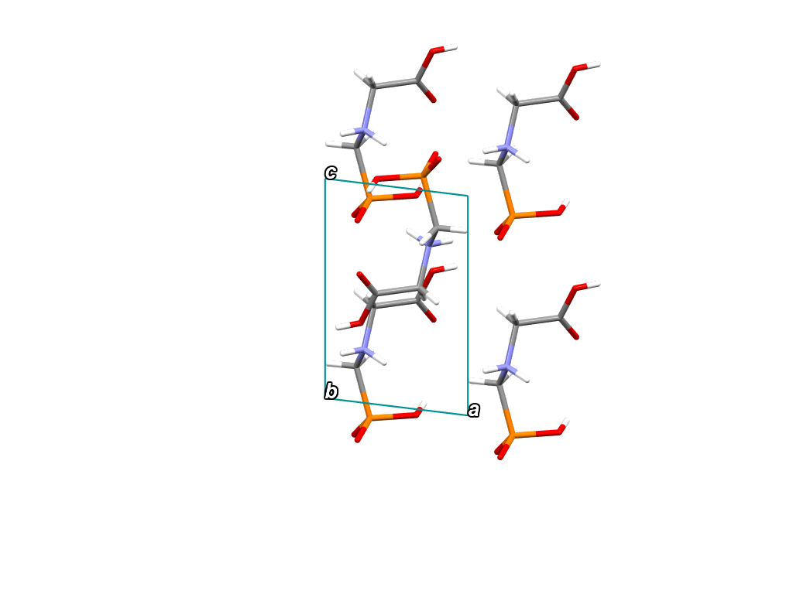

(a) (b)

###### **Figure 1**. Glyphosate packing schemes for (a) phase I at ambient pressure, and (b) phase IV at 6.23 GPa, by viewing down *b* axis.

#### [1] C. Hu, C. J. G. Wilson, D. M. Scully, T. Stuerzer and S. Parsons, *J. Appl. Cryst.*, 2024, **57**, 1691–1696.

#### [2] C. J. G. Wilson, P. A. Wood and S. Parsons, *CrystEngComm*, 2023, **25**, 988–997.

#### [3] C. J. G. Wilson, It’s Not All About U – The Role of Volume and Entropy in Weakly Bound Crystal Structures, PhD Thesis, University of Edinburgh, 2024.