# Awakening *Striga*: cooperative strigolactone perception by the E3 ubiquitin ligase–receptor–substrate complex

## I.A. Vancea1, U.F. Shahul Hameed1, J.C. Moreno1, B. Huntington1, M. Jamil1, A. Balakrishna1, W. Steinchen, C. Savva1, S. Al-Babili1, S.T. Arold1

### 1Biological and Environmental Science and Engineering Division, King Abdullah University of Science and Technology (KAUST), Thuwal 23955-6900, Saudi Arabia. 2Center for Synthetic Microbiology (SYNMIKRO) & Faculty of Chemistry, Philipps-University Marburg, 35043 Marburg, Germany

### stefan.arold@kaust.edu.sa

*Striga* are a family of root-parasitic plants that decimate their host plants by draining their resources (Fig. 1A). The uncontrolled growth of Striga results in billions of euros in losses and contributes to food insecurity. As obligate parasites, their germination in the absence of a suitable host would be suicidal. Therefore, Striga have developed a sophisticated system to eavesdrop on strigolactones, a family of phytohormones released by host plants to attract symbiotic fungi. This perception system is based on a repurposed multiprotein E3 ubiquitin ligase that uses an additional adaptor protein (the receptor) to ubiquitinate the substrate (a transcriptional repressor of germination) in the presentence of host-derived strigolactones. Interestingly, this receptor is a catalytically attenuated α/β-hydrolase that translates substrate binding and slow catalysis into the structural rearrangements it requires to link the E3 ligase with its substrate. Through the combination of several structural methods (X-ray crystallography, cryo-EM, SAXS) with biochemical and functional analyses, we determined the structural landscape of the E3–adaptor–substrate complexes (Fig. 1B). Our work identifies the structural basis for strigolactone perception, underscoring the importance of finely tuned dynamics in E3-based hormone perception, which are difficult to capture in structural analyses (Fig. 1C,D) [1]. We also identified synthetic as well as endogenous compounds that block the structural transformations of the α/β-hydrolase receptor, and thereby inhibit strigolactone perception and signalling [2-4].

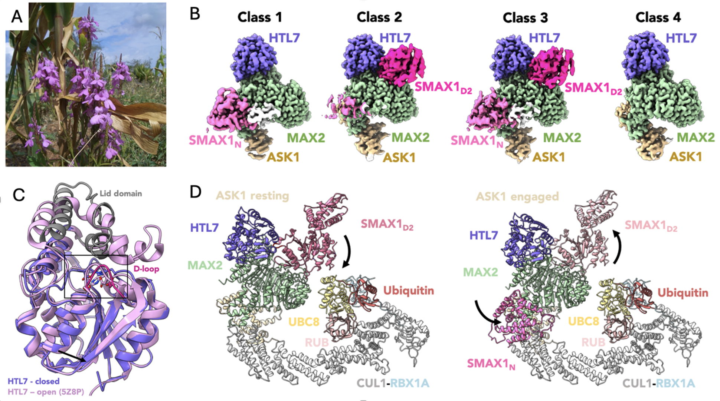

###### **Figure 1**. A) *Striga hermonthica* (pink flowers) decimating crops. B) Structural landscape of the E3–receptor–ligase complex. C) Structures of the receptor pre- (open) and post- (closed) catalysis. D) Model of the signalling complex, showing structural dynamics.

#### [1] Vancea, I.A., Huntington, B., Steinchen, W., Savva, C., Shahul Hameed, U.F., Arold, S.T. (2025) under revision; *bioRxiv* 2024.11.17.623987

#### [2] Moreno, J.C., Shahul Hameed, U.F., Balakrishna, A., Ablazov, A., Liew, K.X., Jamil, M., Mi, J., Alashoor, K., de Saint Germain, A., Arold, S.T., Al-Babili, S. (2025) under revision; *bioRxiv* 2024.07.03.601835

#### [3] Zarban, R.A., Shahul Hameed, U.F., Jamil, M., Ota, T., Wang, J.Y., Arold, S.T., Asami, T., Al-Babili, S. (2022) *Plant Physiol.* 188(2):1369-1384.

#### [4] Shahul Hameed U.F., Haider, I., Jamil, M., Kountche, B.A., Guo, X., Zarban, R.A., Kim, D., Al-Babil,i S., Arold, S.T. (2018) *EMBO Rep*. 19(9):e45619.

We acknowledge support by the King Abdullah University of Science and Technology (KAUST) through funding and core lab access, and SOLEIL for provision of synchrotron radiation facilities.