# Crystal Structure of the TREX1–DNA Mimic Foldamer Complex: A Novel Inhibition Mechanism of the First Foldamer-Based Inhibitor Targeting the Cancer Immunotherapeutic Protein

## Chieh-Yu Tsai1, Ya-Yun Yang1, 2, Valentina Corvaglia3, Jiaojiao Wu3, Kuan-Wei Huang1, 2, Ivan Huc3, *, Yu-Yuan Hsiao1, 2, 3, *

### 1Department of Biological Science and Technology, National Yang Ming Chiao Tung University, Hsinchu, Taiwan, 2Institute of Molecular Medicine and Bioengineering, National Yang Ming Chiao Tung University, Hsinchu, Taiwan, 3Institute of Chemical Epigenetics, Department of Pharmacy, Ludwig-Maximilians University, München, Germany, 4Institute of Bioinformatics and Systems Biology, National Yang Ming Chiao Tung University, Hsinchu, Taiwan

### Mike0617@nycu.edu.tw

DNA mimic (DM) foldamers are synthetic oligomers that emulate the structural and electrostatic properties of double-stranded DNA (dsDNA), enabling interactions with DNA-binding proteins implicated in cancer and viral infections, such as topoisomerase I and HIV integrase[1, 2]. Despite their biomedical potential, structural insights into how DM foldamers engage target proteins have been lacking. Here, we report the first crystal structure of a DM foldamer–disease-associated protein complex, elucidating the molecular mechanism of DM foldamer-mediated inhibition of TREX1, a DNA exonuclease and key immune suppressor involved in cancer immune evasion[3]. Biochemical assays reveal that TREX1 binds DM foldamers with higher affinity than natural dsDNA, with both binding and inhibitory potency increasing in a length-dependent manner. Structural analysis shows that DM foldamers competitively occupy the active site of TREX1(Fig. 1), displacing substrate dsDNA, as confirmed by competitive binding assays. Notably, the DM foldamer adopts an M-exo (minus helicity, left-handed) helical conformation, distinct from the natural P-exo (plus helicity, right-handed) helicity of B-form dsDNA, as validated by circular dichroism spectroscopy. M-exo foldamers exhibit stronger inhibitory activity than their P-exo counterparts, potentially minimizing off-target interactions with normal B-DNA (P-exo helicity)–binding proteins. These findings provide the first structural framework for understanding DM foldamer–protein recognition and establish a foundation for the rational design of selective TREX1 inhibitors in cancer immunotherapy.

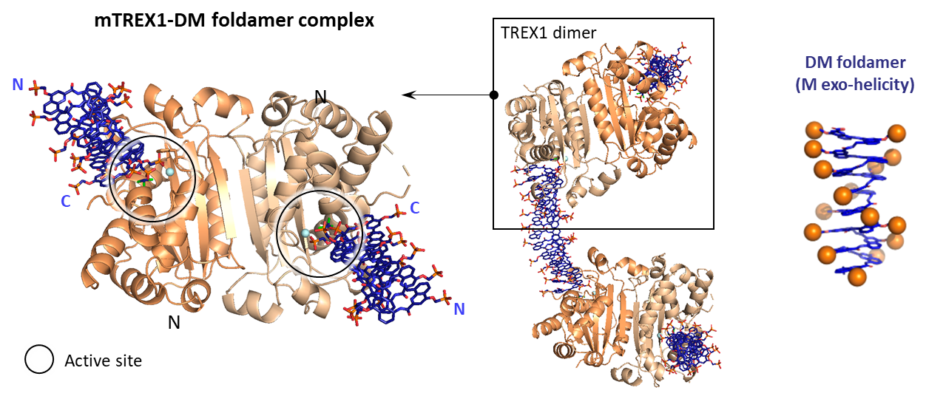

###### **Figure 1**. Crystal structure of TREX1-DM foldamer complex.

[1] Ziach, K.; Chollet, C.; Parissi, V.; Prabhakaran, P.; Marchivie, M.; Corvaglia, V.; Bose, P. P.; Laxmi-Reddy, K.; Godde, F.; Schmitter, J. M.; Chaignepain, S.; Pourquier, P.; Huc, I., (2018), Nat Chem, 10 (5), 511-518.

[2] Corvaglia, V.; Carbajo, D.; Prabhakaran, P.; Ziach, K.; Mandal, P. K.; Dos Santos, V.; Legeay, C.; Vogel, R.; Parissi, V.; Pourquier, P.; Huc, I., (2019), Nucleic Acids Res, 47 (11), 5511-5521.

[3] Tani, T.; Mathsyaraja, H.; Campisi, M.; Li, Z. H.; Haratani, K.; Fahey, C. G.; Ota, K.; Mahadevan, N. R.; Shi, Y.; Saito, S.; Mizuno, K.; Thai, T. C.; Sasaki, N.; Homme, M.; Yusuf, C. F. B.; Kashishian, A.; Panchal, J.; Wang, M.; Wolf, B. J.; Barbie, T. U.; Paweletz, C. P.; Gokhale, P. C.; Liu, D.; Uppaluri, R.; Kitajima, S.; Cain, J.; Barbie, D. A., (2024), Cancer Discov, 14 (5), 752-765.