# *In*-operando battery study of NMC811 and beyond: What a benchtop XRD can achieve

## S. Welzmiller1, W. Ju2, C. Giacobbe1

### 1Thermo Fisher Scientific, Chemin de Varney 2, 1024 Ecublens Switzerland, 2Thermo Fisher Scientific, 2517 Jinke Road, Pudong, Shanghai, China

### Email of communicating: simon.welzmiller@thermofisher.com

This study demonstrates the capabilities of benchtop X-ray diffraction for investigating structural dynamics in both conventional and next-generation battery materials. By utilizing PYTHON scripts on large datasets, it is possible to conveniently correlate analytical data from different sources. Initially, we present a detailed in-operando analysis of LiNi0.8Mn0.1Co0.1O2 (NMC811) cathode materials during electrochemical cycling (cf. Figure 1 left). Under controlled conditions (2.7-4.3V), two complete charge-discharge cycles revealed significant structural transformations. Derived from Rietveld refinements of NMC811 [2] using Profex [1], during charging, the *c* lattice parameter expanded from 1.42 nm to 1.45 nm, while the *a* parameter contracted from 0.284 nm to 0.281 nm, corresponding to lithium deintercalation (cf. Figure 1 right). The material demonstrated high specific capacity (180 mAh/g) [3-5] and excellent Coulombic efficiency (91.8% first cycle, 99.8% second cycle). Equally, it is possible to extend such an investigation to solid-state batteries utilizing e.g. sulfide-based electrolytes (Li2S-P2S5 system), where XRD analysis enables monitoring of interfacial reactions and structural stability during cycling. Therefore, a specialized test cell needs to be used to pressurize the solid-state electrolyte. The methodology successfully tracks phase evolution and potential degradation mechanisms in both the cathode material and the solid electrolyte, providing crucial insights for optimizing these next-generation battery systems. This comprehensive approach demonstrates how benchtop XRD can effectively support the development of both conventional and solid-state battery technologies.

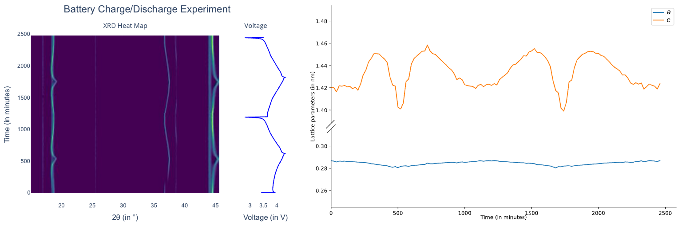

###### **Figure 1**. XRD Heat map correlated with the voltage curve of the potentiostat and trend of *a* and *c* of two charge / discharge cycles of NMC 811.

#### [1] Döbelin, N. & Kleeberg, R. (2015). *J. Appl. Crystallogr.* **48**, 1573.

#### [2] Arai, H., Tsuda, M. & Sakurai, Y. (2000). *J. Power Sources* **90**, 76.

#### [3] Schmuch, R., Wagner, R., Hörpel, G., Placke, T. & Winter, M. (2018). *Nat. Energy* **3**, 267-278.

#### [4] Myung, S.-T., Maglia, F., Park, K.-J., Yoon, C.S., Lamp, P., Kim, S.-J. & Sun, Y.-K. (2017). *ACS Energy Lett.* **2**, 196.

#### [5] Schipper, F., Erickson, E.M., Erk, C., Shin, J.-Y., Chesneau, F.F. & Aurbach, D. (2016). *J. Electrochem. Soc*. **164**, A6220.