Reconstruction of Polarization and Correlation effect in Molecular Crystals Through the Lens of One-Electron Reduced Density Matrix

S. Yu^{1*}, J.-M. Gillet¹

¹Structures, Properties and Modelling of Solids lab., CentraleSupelec, Paris-Saclay University, 3 rue Joliot-Curie, 91191 Gif-sur-Yvette, France

sizhuo.yu@centralesupelec.fr
Recent advances in quantum crystallography have demonstrated that conventional crystallographic measurements such as X-ray diffraction and Compton scattering can be used to determine electronic behaviour in crystals on a deeper level [1-3]. Among these developments, the one-electron reduced density matrix (1-RDM) plays a pivotal role, offering a direct quantum mechanical description at the one-electron level while being closely related to measurable experimental data. Through a series of work, it has been shown that an ensemble N-representable 1-RDM can be reconstructed for molecular crystals from the joint refinement against X-ray diffraction structure factors (SFs) and inelastic scattering directional Compton profiles (DCPs) [4-6].
While the principle of reconstructing 1-RDM has been proven, the level of accuracy that can be expected from the reconstruction is still unclear. In general, the modification to the electronic wavefunction due to the polarization effect caused by intramolecular interactions and the correlation effects caused by instantaneous electron-electron repulsion are much subtler than those induced by chemical bonding. Consequently, the footprint of such effects in the measurement data are smaller and therefore their reconstruction via the 1-RDM is more challenging.
We have recently investigated the polarization and correlation effects through the 1-RDM reconstruction method, applied to artificial data generated from theoretical computations on the molecular crystal of urea. Particular attention was given to the influence of introducing experimental statistical noise on the artificial data and the impact of including the DCP measurements into the reconstruction process. Several interesting observations have been made based on our results, including the impact of DCP data on the position space density and the 1-RDM, and the difference between the reconstructions of polarization and correlation effects. Our results provide insights into the fundamental challenges of 1-RDM reconstruction and lay the groundwork for future methodological developments.
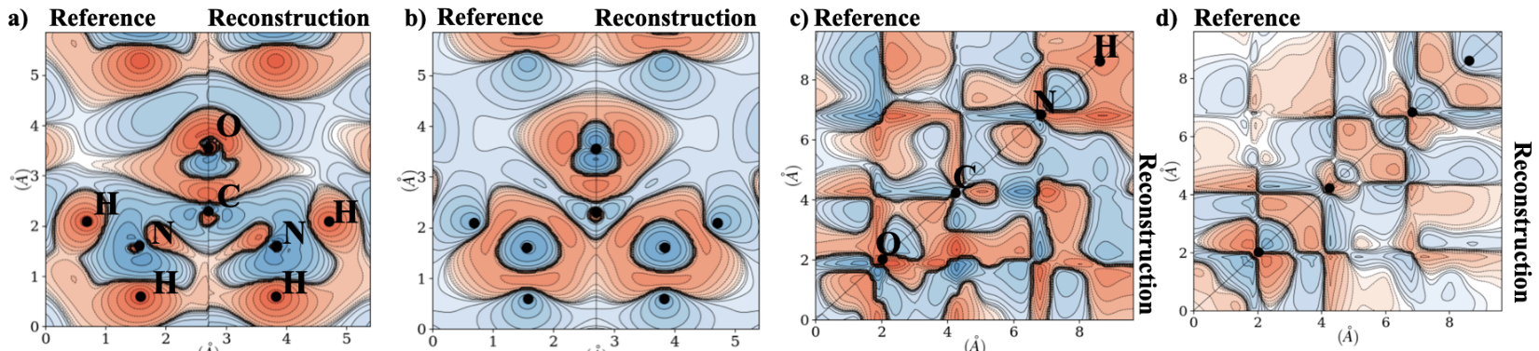

Figure 1. (a) The theoretical and reconstructed polarization density on the molecular plane. (b) The theoretical and reconstructed correlation density on the molecular plane. (c) The theoretical and reconstructed polarization 1-RDM on the O-C-N-H path. (d) The theoretical and reconstructed correlation 1-RDM on the O-C-N-H path.

[1] Tsirelson, V., J. Comput. Chem., 39.17 (2018): 1029-1037
[2] Genoni, A. and Macchi, P., Crystals 10.6 (2020): 473
[3] Massa, L. and Matta, C. F., J. Comput. Chem., 39.17 (2018): 1021-1028
[4] De Bruyne, B. and Gillet, J.-M., Acta Cryst. A, 76.1 (2020): 1-6
[5] Launay, Y., and Gillet, J.-M., Acta Cryst. B, 77.5 (2021): 683-694
[6] Yu, S. and Gillet, J.-M., Acta Cryst. A, 80.3 (2024): 249-257

