# Investigation of the anharmonic atomic motion in molecular crystals using the GFN2-XTB molecular dynamics approach

## Patzer M.1, Lehmann C. W.1

### 1Max-Planck-Institut für Kohlenforschung, Chemische Kristallographie und Elektronenmikroskopie, Mühlheim an der Ruhr, Germany

### patzer@kofo.mpg.de

The major research interest of the quantum crystallographic approach is to evaluate the experimental diffraction intensities with quantum mechanical methods in order to provide new insights for both theory and experiment. Originally starting with the refinement of the charge density using complex parameter models such as the Hansen-Coppens multipole model, the theory-based Hirshfeld Atom Refinement model (HAR) is presently almost sufficient to describe the electron density around the nucleus. In general, the Quantum Crystallography methods contribute decisively to the successful deconvolution of the atomic displacements and static electron density. [1]

The atomic displacement, or more particularly, the thermal smearing of the electron density due to the movement of a nucleus, is more difficult to predict. An approach called Normal Mode Refinement has been developed by the group of Madsen, in which frequencies of the low frequency modes calculated with the periodic density functional theory are refined. A scaling is necessary because of significant differences between the predicted and experimental frequencies. [2]

In this case study we present an alternative approach to predict the atomic displacements accurately. Molecular dynamics simulations (NVT, GFN2-XTB [3]) are used to calculate ab initio dynamic structure factors. These simulations can be used to predict anisotropic displacement and anharmonic motion numerically. [4] The aim is to achieve the best possible agreement between theory and experiment and to put the current models to the test.

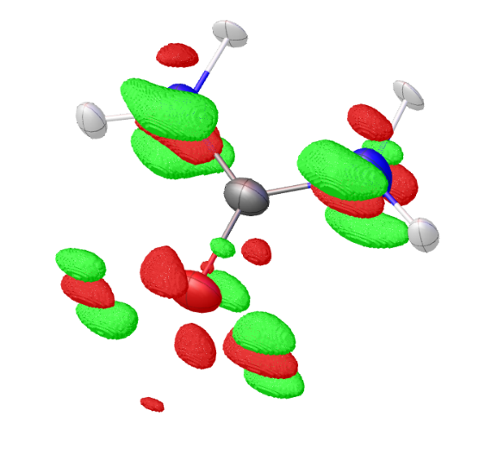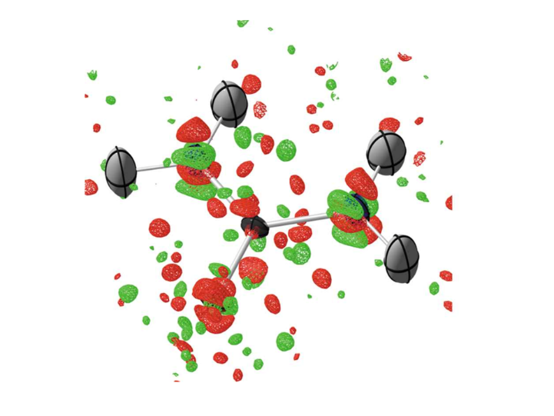

theory (this work) reference [5]

###### **Figure 1**. Residual density in the urea crystal due to anharmonic motion: (1) Theory: 120 ps simulation time; approx. 120 K; isosurface: 0.03 e/A³ (this work). (2) Experiment [5]: PAW-HAR; 123 K; isosurface: 0.04 e/A³; green: positive; red: negative.

#### [1] Krawczuk, A. & Genoni, A. (2024). *Acta Crystallographica Section B* **80**, 249-274.

#### [2] Hoser, A. A. & Madsen, A. O. (2016). *Acta Crystallographica Section A* **72**, 206-214.

#### [3] Bannwarth, C., Ehlert, S. & Grimme, S. (2019). *Journal of Chemical Theory and Computation* **15**, 1652-1671.

#### [4] Reilly, A. M., et al. (2013). *Journal of Applied Crystallography* **46**, 656-662.

#### [5] Ruth, P. N., Herbst-Irmer, R. & Stalke, D. (2022). *IUCrJ* **9**, 286-297.