# Pb4Sr14Fe23O52 : its complex crystal structure finally solved thanks to 3D ED

## C. Lepoittevin1

### 1Université Grenoble-Alpes, CNRS, Grenoble INP, Institut Néel, 38000 Grenoble

### christophe.lepoittevin@neel.cnrs.fr

The strontium ferrites and cobaltites, (Sr4-xCaₓ)(Fe6-ᵧCoᵧ)O13±δ, exhibit mixed ionic-electronic conductivity [1], and thermoelectric properties [2], both strongly influenced by oxygen non-stoichiometry. The incommensurately modulated structure of Sr₄Fe₆O13±δ was precisely characterized using single-crystal X-ray diffraction and refined within the 4D formalism [3].

To introduce structural distortions into this phase, Sr²⁺ was partially replaced by the isovalent cation Pb²⁺. Despite having a similar ionic radius to Sr²⁺, Pb²⁺ induces significant distortions due to its stereochemically active 6s² lone pair. This substitution led to the discovery of a new phase in 2006, for which a preliminary structural model was proposed using zone-axis electron diffraction and High-Resolution Transmission Electron Microscopy (HRTEM)[4] . However, due to the structural complexity, a complete solution could not be achieved with the tools available at the time.

Recent advances in 3D Electron Diffraction (3D ED), coupled with the high performance of modern Transmission Electron Microscopes and cameras, have now made it possible to solve such complex structures. This progress provided the impetus to revisit the previously unsolved phase and complete its structural determination.

To achieve this, a -60° to +60° dataset was acquired using a JEOL NEOARM microscope and processed with the PET2 software [5]. The structural model was initially calculated using the charge flipping algorithm [6] in JANA2020 [7]. It was first refined kinematically to identify missing oxygen atoms via the Difference FFT method, and subsequently refined using dynamical diffraction theory. The structure was found to crystallize in a monoclinic unit cell with the parameters *a* = 36.879(10) Å, *b* = 5.803(2) Å, *c* = 26.231(8) Å, β = 98.83(3)°, in the *C2/c* space group. The final model was confronted to STEM-HAADF imaging and showed excellent agreement (fig. 1 a and b).

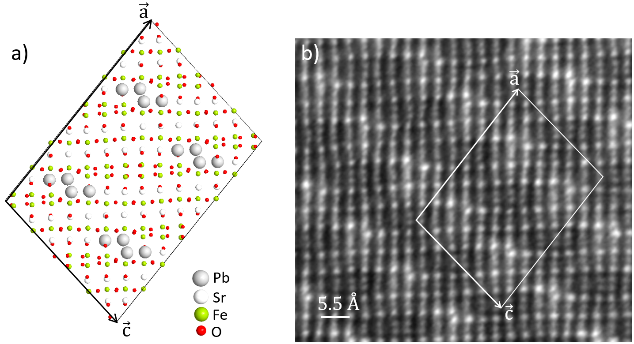

###### **Figure 1**. a) Structure of Pb4Sr14Fe23O52 after dynamical refinement and b) STEM HAADF image

Acknowledgements. The TEM facility JEOL NEOARM at CNRS Institut Néel was co-financed by the European Union under the European Regional Development Fund (ERDF, contract no. RA0023813).

[1] Steele B.C.H. (1992). *Mater. Sci. Eng. B*, **13**, 79.

[2] Guggilla S., Armstrong T. & Manthiram A. (1999). *J. Solid State Chem*., **145**, 260.

[3] Pérez O., Mellenne B., Retoux R., Raveau B. & Hervieu M., (2006). *Solid State Sci*., **8**, 431.

[4] [Lepoittevin](http://www.sciencedirect.com.gate4.inist.fr/science/article/pii/S1293255806002123) C., [Malo](http://www.sciencedirect.com.gate4.inist.fr/science/article/pii/S1293255806002123) S., [Pérez](http://www.sciencedirect.com.gate4.inist.fr/science/article/pii/S1293255806002123) O., [Nguyen](http://www.sciencedirect.com.gate4.inist.fr/science/article/pii/S1293255806002123) N., [Maignan](http://www.sciencedirect.com.gate4.inist.fr/science/article/pii/S1293255806002123) A. & [Hervieu](http://www.sciencedirect.com.gate4.inist.fr/science/article/pii/S1293255806002123) M. (2006). *Solid State Sci*., **8**, 1294.

[5] Palatinus L., Brázda P., Jelínek M., Hrdá J., Steciuk G. & Klementová M. (2019). *Acta Cryst B*, **75** (4), 512–522.

[6] Palatinus L. (2013). *Acta Cryst B*, **69** (1), 1–16.

[7] Petříček V., Palatinus L., Plášil J. & Dušek M. (2023). *Zeitschrift für Kristallographie - Crystalline Materials*.