# Synthesis of Heterometallic Rare Earth-Zinc Aryloxido Complexes for Catalytic Applications

## A. Kowaliński1, R. Petrus1

### 1Faculty of Chemistry, Wrocław University of Science and Technology, 23 Smoluchowskiego, 50-370 Wrocław, Poland

### adrian.kowalinski@pwr.edu.pl

Over the past three decades, heterometallic rare earth metal-zinc coordination compounds have gained attention as valuable molecular materials due to their remarkable magnetic, photochemical, catalytic, and structural characteristics [1-4]. The synthesis of REIII-ZnII complexes presents a promising approach to enhancing catalytic performance, offering improved reaction efficiencies and selectivity in various chemical transformations. In polymer and resin synthesis, these complexes can facilitate controlled polymerization processes, leading to advanced materials with tailored properties such as enhanced stability, mechanical strength, or thermal resistance.

In our work, we developed a simple synthetic route to REIII-ZnII coordination compounds by reacting homoleptic or heteroleptic zinc aryloxides, [Zn4(sal-Me)8] and [Zn4(μ3-OMe)2(sal-Me)6] (Hsal-Me = methyl salicylate) with 2 equiv of RECl3 [5]. Depending on the zinc aryloxide precursor used, the formation of either trinuclear heterometallic clusters [REZn2(sal-Me)4Cl3(H2O)] (REIII = Y, Ho, Er) using the first one or hexanuclear clusters [RE2Zn4(μ3-OH)2(μ-OMe)2(sal-Me)6Cl4] (REIII = Y, Ho, Er) using the second one was observed. The catalytic activities of homometallic and heterometallic compounds were investigated in the ring-opening polymerization (ROP) of pentadecanolide (PDL) and hexadecanolide (HDL), leading to the synthesis of low molecular weight materials, as pictured in Fig. 1.

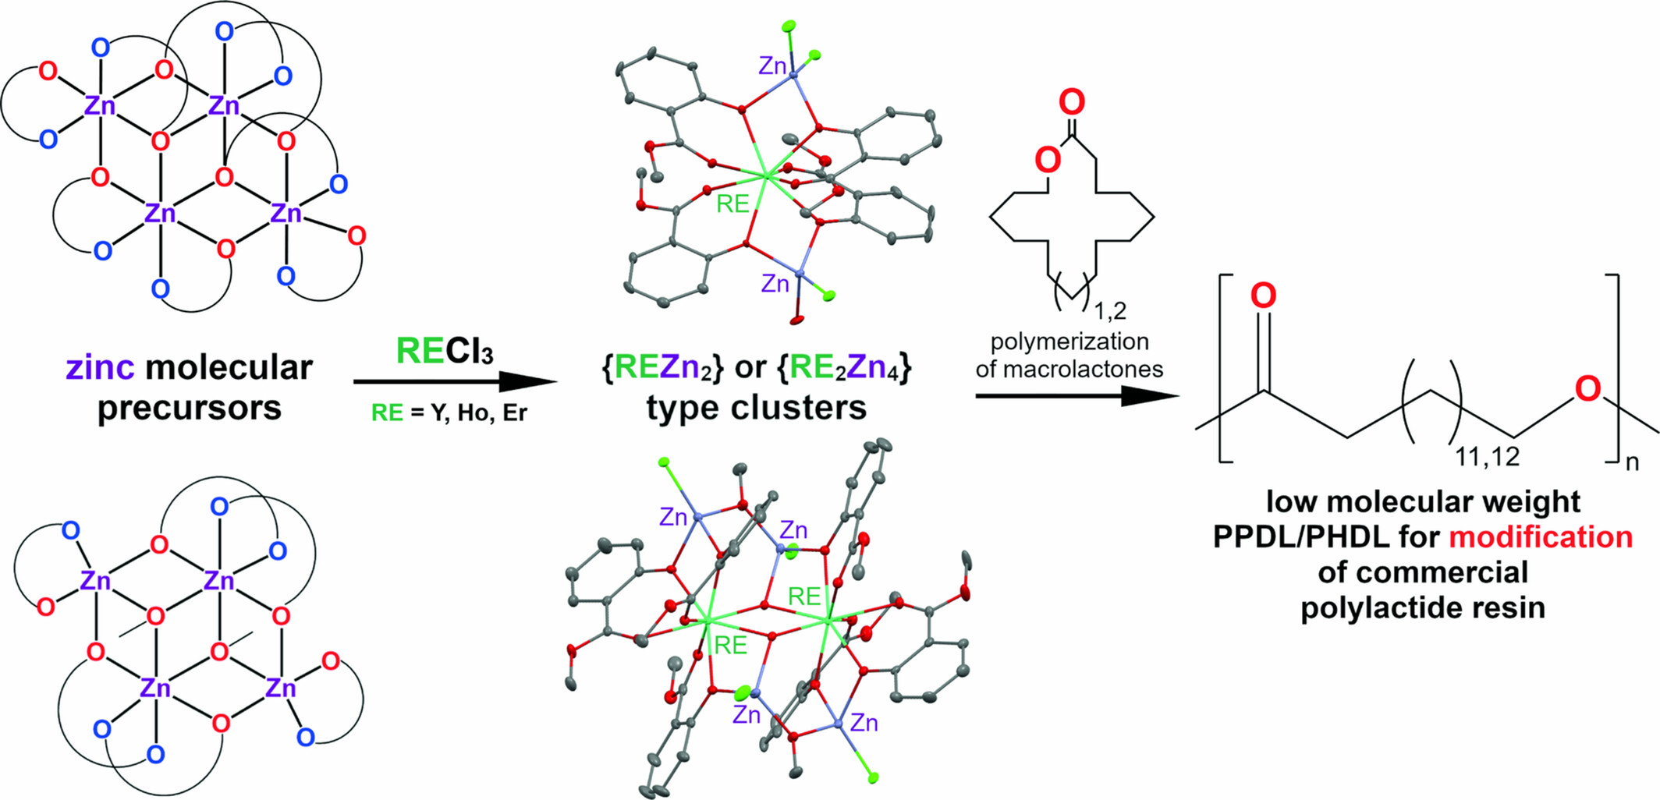

###### **Figure 1**. Synthesis of {REZn2} and {RE2Zn4} type clusters for polymerization of macrocyclic lactones.

The low molecular weight polyesters (PPDL and PHDL) were examined as modifying agents for commercial polylactide resin (PLLA 2003D) and used to create PLLA/PPDL and PLLA/PHDL blends. Incorporating PPDL or PHDL into PLLA expanded its cold crystallization exotherm, increased its Tcc, hindered PLLA crystal growth, and resulted in reduced thermal stability and faster degradation. Currently, we are working on using the obtained complex compounds in the synthesis of alkyd resins.

#### [1] B. Zheng, J. Fan, B. Chen, et al., “Rare-Earth Doping in Nanostructured Inorganic Materials,” Chemical Reviews 122 (2022): 5519–5603.

#### [2] A.-L. Boulkedid, A. Beghidja, C. Beghidja, Y. Guari, J. Larionova, and J. Long, “Synthesis, Structure and Magnetic Properties of a Series of Dinuclear Heteroleptic Zn2+/Ln3+ Schiff Base Complexes: Effect of Lanthanide Ions on the Slow Relaxation of Magnetization,” Dalton Transactions 48 (2019): 11637–11641.

#### [3] Y.-L. Li, H.-L. Wang, Z.-C. Chen, et al., “Lanthanoid Hydrogen-Bonded Organic Frameworks: Enhancement of Luminescence by the Coordination-Promoted Antenna Effect and Applications in Heavy-Metal Ion Sensing and Sterilization,” Chemical Engineering Journal 451 (2023): 138880.

#### [4] C.-L. Yin, Z.-B. Hu, Q.-Q. Long, et al., “Single Molecule Magnet Behaviors of Zn4Ln2 (Ln = DyIII, TbIII) Complexes With Multidentate Organic Ligands Formed by Absorption of CO2 in Air Through In Situ Reactions,” Dalton Transactions 48 (2019): 512–522.

#### [5] A. Kowaliński, R. Petrus, K. Chomiak, and T. Lis, ”Synthesis of Heterometallic Rare Earth-Zinc Aryloxido Complexes and Their Application in Macrocyclic Lactones Polymerization,” Applied Organometallic Chemistry 39 (2025): e70017.

Participation in the 35th European Crystallographic Meeting was financed by the National Science Centre, Poland under Grant No. 2024/53/N/ST4/01322.