BioStIn-E: Towards an Individualized Path to Self-Learning in Integrative Structural Biology

MH Le Du¹

¹ CEA/DRF/JOLIOT/SB2SM, Bat 532, CEA Saclay, 91190 Gif-sur-Yvette, FRANCE

marieheleneledu@gmail.com
The accelerated development of integrative structural biology (ISB) in biological laboratories demands a high level of expertise that must be acquired increasingly rapidly. This expertise spans disciplines such as biochemistry, chemistry, physics, mathematics, and computer science. However, there is a risk that the knowledge in each of these disciplines may remain overly superficial, leading to erroneous results or time wasted due to poor decisions.
Several sessions of the MOOC "Journey into the Heart of Living Matter with X-rays: Crystallography" have shown two issues with this approach, especially when training students who will become our future structural biologists. The first involves the time constraint related to the MOOC's availability period, as students may join a laboratory at any time of the year and need immediate training. The second concerns the content itself, which remains traditional by presenting the same information throughout the MOOC. Since students come from varied backgrounds, this classical approach can be too easy at times and too challenging at others.
During this presentation, I will discuss the development of the Biostin-e self-learning website for integrative structural biology. The general idea is to enable students to acquire the fundamentals of structural biology, regardless of their initial background. This 'à la carte' introduction allows students to assess their knowledge through a quiz for each relevant discipline. Based on the quiz results, they can either proceed to the next topic or watch a training video covering the domain evaluated in the quiz.

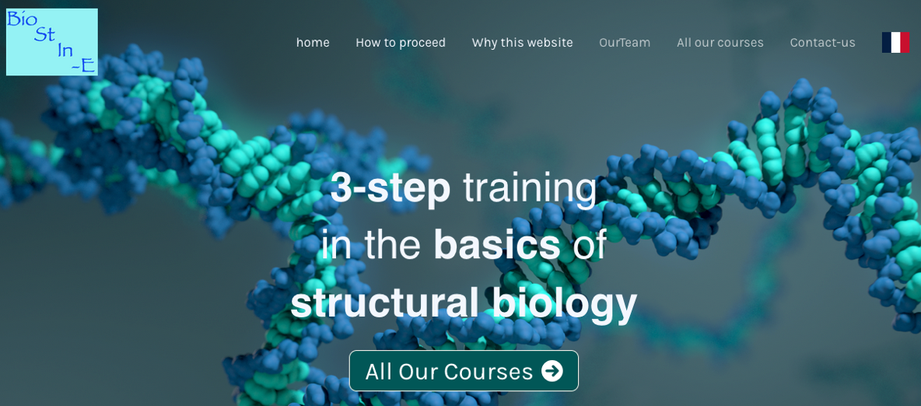

Figure 1. Header of Biostine website : https://www.biostine.fr/home-biostine

