# Using long-wavelength X-ray diffraction to localise light atoms in macromolecular crystals

## R. Duman1, K. El Omari1, C. Orr1, V. Mykhaylyk1 and A. Wagner1

### Diamond Light Source, Harwell Science and Innovation Campus, Fermi Avenue, Didcot, OX11 0DE

### ramona.duman@diamond.ac.uk

Long wavelength X-ray diffraction experiments enable the measurement of weak anomalous signal from biologically relevant ions (Ca2+, K+, Cl-, Mg2+) and elements, such as S and P, natively found in macromolecules. Beamline I23 [1] at Diamond Light Source, UK, is a unique instrument operating in a wavelength range between 1 and 5 Å, designed to target the absorption edges of many such light elements. This can be used to confirm their binding sites within macromolecules [2] or solve structures by native experimental phasing using single-wavelength anomalous diffraction (SAD) [3]. Correct assignment of ions in macromolecular structures is of increasing importance, given the rapid development of structure prediction tools which train on published structures, many of which contain errors. To make these experiments possible, while mitigating the increased absorption of long wavelengths X-rays by air, the sample environment on beamline I23 is a highly specialised in-vacuum setup, which incorporates a curved detector and multi-axis goniometry. Measurements at the longest wavelengths (> 4 Å) are impacted by sample absorption, which can be rectified by two methods. Laser shaping can be used to create spherical crystals and remove non-diffracting material or analytical absorption correction factors can be calculated, based on a 3D model of the sample provided by X-ray tomography [4]. Examples will be shown of recent studies contributing to enhanced functional understanding of enzymes and ion channels through targeted ion identification experiments. The successful use of anomalous signal from light atoms, as a tool for placing partially occupied fragments in drug binding studies, will also be showcased.

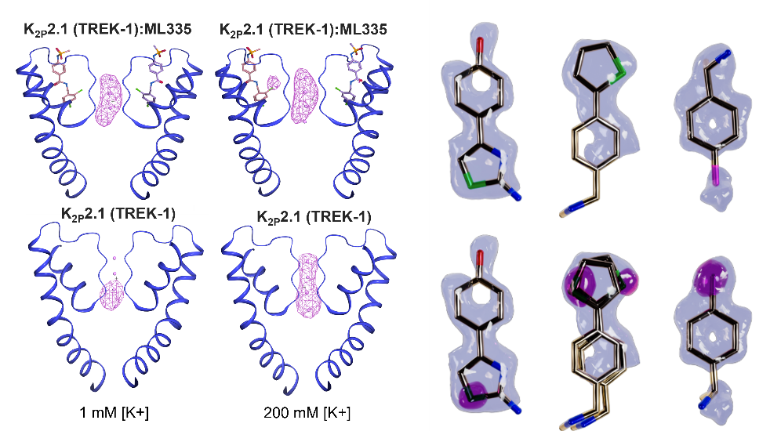

###### **Figure 1**: Anomalous difference Fourier maps (magenta, 4 σ) from data taken at λ = 2.75 Å. Left: the selectivity filter of K2P potassium channel [5] showing concentration-dependent ion occupancy. Right: Ligands from a fragment-based drug design study targeting SARS-CoV-2 NSP1 protein [6]​; anomalous peaks (magenta) from Sulfur (green) and Chloride (pink) atoms in partially occupied fragments, overlaid on the 2fo-fc electron density (grey).

#### [1] Wagner, A et al (2016). Acta Cryst. D72, 430–439.

#### [2] El Omari, K. et al (2024). Acta Cryst. D80.

#### [3] El Omari, K., et al (2023) Commun Chem 6, 219

#### [4] Lu Y. et al (2024) J. Appl. Crystallogr., 57

#### [5] Lolicato, M. et al (2020) Sci. Adv., 6(44)

#### [6] Ma s. et al. (2023) Int. J. Mol. Sci. 24(13), 11197