# Racemic crystal structure of a synthetic DNA hairpin with diquinoline linker

## P.K. Mandal1, M. Loos2, F. Xu2, I. Huc2

### 1Institute of Science and Technology Austria (ISTA), Am Campus 1, 3400 Klosterneuburg, Austria, 2Ludwig-Maximilians-Universität München (LMU), Butenandtstr. 5-13, 81377 München, Germany

### Email of communicating author Pradeep.Mandal@ist.ac.at

The commercial availability of affordable L-DNA sequences and the ease to obtain diffraction-quality crystals make racemic DNA crystallography an attractive alternative to conventional crystallization using D-enantiopure solutions alone [1]. The approach enabled the crystallization of an intractable biologically-relevant DNA sequence, the Pribnow box consensus promoter sequence TATAAT [2] and identify structural form of a DNA sequence that has not previously been observed for the enantiopure equivalent [3].

The racemic DNA approach recently enabled us to obtain diffraction-quality crystals of a synthetic hairpin DNA with segments d(GT4G) and d(CA4C) conjugated with a diamide quinoline linker unit. While the D-enantiomer of this hairpin DNA yielded crystals with weak, DNA fiber-like diffraction pattern; the racemic mixture of hairpin DNA yielded crystals that diffracted to a resolution of 2.5 Å and belonged to centrosymmetric space group *P*-1 [4].

The racemic crystal structure validated the design and synthesis of the linker unit to serve as a hairpin turn in a DNA duplex and function as an anchor point for an aromatic helical foldamer mimicking the shape and surface properties of B-DNA [5]. The crystal structure complemented with circular dichroism (CD) and molecular models demonstrated the ability of the linker to position the foldamer helix and the duplex DNA so that their rims and grooves are aligned despite their completely different chemical nature.

#### [1] Mandal, P.K.., Collie, G.W., Kauffmann, B. & Huc, I. (2014). *Angew. Chem. Int. Ed.* **53**, 14424.

#### [2] Mandal, P.K.., Collie, G.W., Srivastava, S.C., Kauffmann, B. & Huc, I. (2016). *Nucleic Acids Res.* **44**, 5936.

#### [3] Mandal, P.K.., Collie, G.W., Kauffmann, B. & Huc, I. (2022). *Acta Crystallogr., Sect. D: Struct. Biol.* **78**, 709.

#### [4] Loos, M., Xu, F., Mandal, P.K., Chakrabortty, T., Douat, C., Konrad, D., Cabbar, M., Singer, J., Corvaglia, V., Carell, T. & Huc, I. (2025). *Angew. Chem. Int. Ed.* doi.org/10.1002/anie.202505273.

#### [5] Ziach, K., Chollet, C., Parissi, V., Prabhakaran, P., Marchivie, M., Corvaglia, V., Bose, P.P., Laxmi-Reddy, K., Godde, F., Schmitter, J.-M., Chaignepain, S., Pourquier, P. & Huc, I. (2018). *Nat. Chem.* **10**, 511.

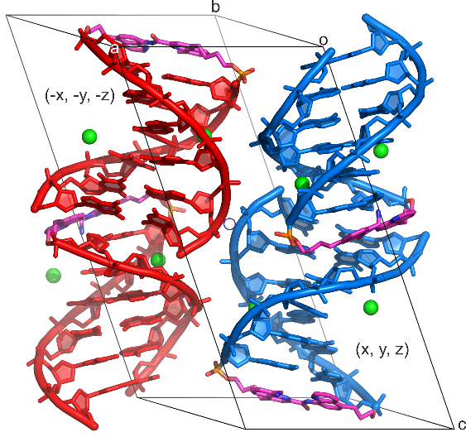

###### **Figure 1**. Unit cell arrangement of hairpin DNA in *P*-1 space group. A blue circle represents the point of inversion. The L and D hairpins are coloured in red and blue, respectively. The linker atoms are coloured magenta, red, blue and orange for C, O, N and P respectively. Mg2+ ions are shown as green spheres. The asymmetric unit consists of two right-handed D hairpins in (x, y, z).