# 3-Dimensional electron diffraction and *in-situ* activation of metal organic frameworks

## Calum S. Sangster1, Jeremiah P. Tidey2, Matthew Snellgrove3, Ashleigh Fletcher3, Gavin Craig3 and Simon Parsons1

### 1Centre for Science at Extreme Conditions, Peter Guthrie Tait Road, University of Edinburgh, Edinburgh EH9 3FD

### 2National Crystallography Service, Dept. Physics, Gibbet Hill Road, Coventry, CV4 7AL

### 3Department of Pure & Applied Chemistry, 295 Cathedral St, University of Strathclyde, Glasgow G1 1BX

### c.s.sangster@sms.ed.ac.uk

Recent developments in electron diffraction are particularly important for research in porous materials, which are notorious for yielding very small crystals which are unsuitable for single-crystal X-ray methods. The porous copper metal organic polyhedral system [Cu4(EtOL)4(H2O)2(DMF)2] (**1**), where LH2 = 3,3’-((5-ethoxy-1,3-phenylene)bis(ethyne-2,1-diyl))dibenzoic acid [1], can be activated for gas sorption by exchange of DMF for MeOH (**2**) followed by removal of the MeOH using a vacuum oven. This results in fracturing of the sample into a rod-like morphology with typical dimensions of 0.3 x 5 m. Powder X-ray diffraction shows that the sample retains high crystallinity but has undergone a phase change.

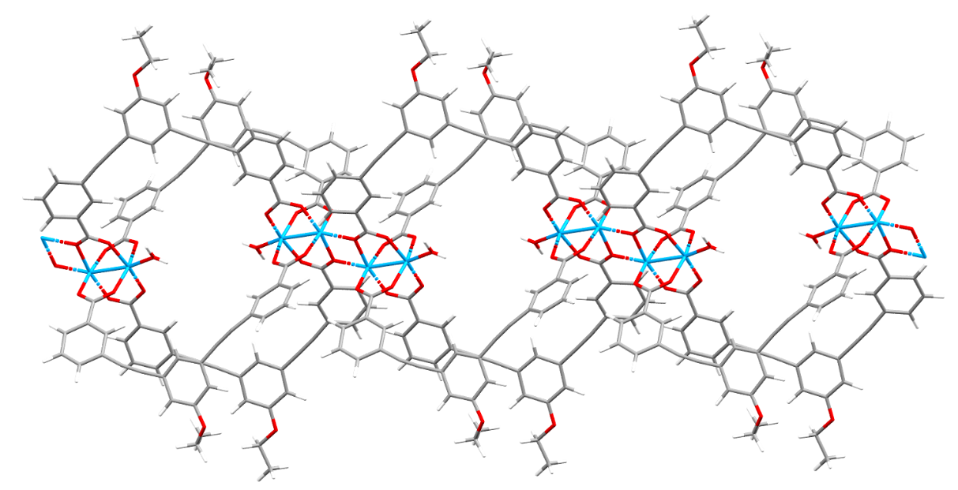

Using 3-dimensional electron diffraction (3D ED) at 100 K, the structure of the solvent exchanged sample was identified as a 1D metal organic framework (MOF) where bridging across inversion centres links the complexes into chains which run along the crystallographic c-axis, Fig. 1. Coordinated waters, oriented towards the interior of the pore, complete the five-fold coordination environment of the copper atoms. The sample was withdrawn from the column of the microscope and warmed to 210 K in the vacuum chamber of the electron diffractometer and then reintroduced into the instrument. Recollection of diffraction data from the same crystallites measured at 100 K revealed that dehydration occurs to generate an ordered phase in which the orientation of the principal crystallographic directions is conserved but with a doubling of the unit cell volume. By contrast, dehydration of previously unirradiated crystallites yields a disordered phase with a unit cell volume which is slightly smaller than that of the hydrated sample and one-half that of the ordered phase. Only one other example of *in situ* MOF activation has been reported [2]. This highlights the suitability for electron diffraction for studying *in situ* MOF activation and polymorphism.

###### **Figure 1**: 3 repeat units of the molecular structure of the hydrated MOF(**2**) obtained from 3D ED.

#### [1] Craig, G. A., Larpent, P., Kusaka, S., Matsuda, R., Kitagawa, S. & Furukawa, S. (2018). *Chemical Science* **9**, 6463-6469.

#### [2] Quintelier, M., Hajizadeh, A., Zintler, A., Gonçalves, B. F., Fernández de Luis, R., Esrafili Dizaji, L., Vande Velde, C. M. L., Wuttke, S. & Hadermann, J. (2024). *Chemistry of Materials* **36**, 7274-7282.