**Crystal Engineering of Bismuth Iodide Derivatives**

**for Physical Reservoir Computing**

Ewelina Cechosz,1 Gisya Abdi,1 Marlena Gryl,2 Ahmet Karacali,3 Alif Syafiq Kamarol Zaman,3

Andrzej Sławek,1 Hirofumi Tanaka,3 Konrad Szaciłowski1,4

1 Academic Centre for Materials and Nanotechnology, AGH University of Krakow, Poland

2 Faculty of Chemistry, Jagiellonian University, Krakow, Poland

3 Research Center for Neuromorphic AI Hardware, Kyushu Institute of Technology, Kitakyushu, Japan

4 Unconventional Computing Laboratory, University of the West of England, Bristol, UK

This study comprises three parts: (i) an investigation into the impact of anionic composition on the crystal structure and semiconducting properties of a series iodobismythate complexes followed by (ii) an assessment of their memristive and plasticity properties in thin layer devices as well as (iii) their possible applications in physical reservoir computing. The presence of different halides induces structural alterations results in the crystals and result in the formation of low dimensional anionic halobismuthate fragments, as confirmed by crystallographic analysis. Diffusion reflectance spectroscopy was used to conduct an experimental investigation into the nature of the optical band gap of these materials, and the results were in good agreement with values based on density functional theory calculations. Due to solubility reasons only bismuth iodide complexes were examined in electronic applications. The current-voltage scans of the devices reveal characteristic pinched hysteresis loops, a distinct signature of memristors. Conductivity versus temperature study indicates combined ionic and electronic contributions to conductivity of the devices. Given that a memristor can function as a single synapse without the need for programming, aligning with the requirements of neuromorphic computing, the study investigated long-term depression, potentiation, and spike-time-dependent plasticity. As the LTP-LTD plots showed non-linearity with fading memory, these materials can be a good candidate for application in physical reservoir computing. To further assess this materials, two different apaches towards reservoir computing has been implemented: an electronic devices with sixteen gold electrodes, featuring one input and 15 output ports integrated on silicon substrate and one input-open output circuit equipped with a delayed feedback. Both approaches has been found to be useful for complex computational tasks in pattern recognition and signal classification: recognition of hand-written digits and detection of vocalizations of *Trichosurus Vulpecula*.

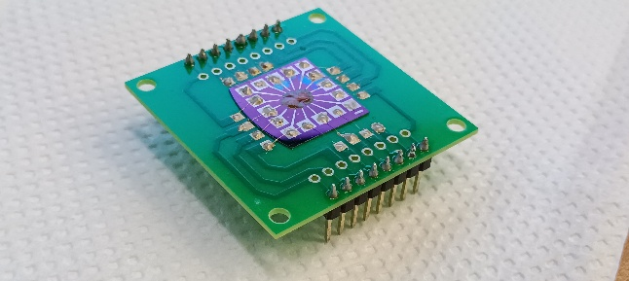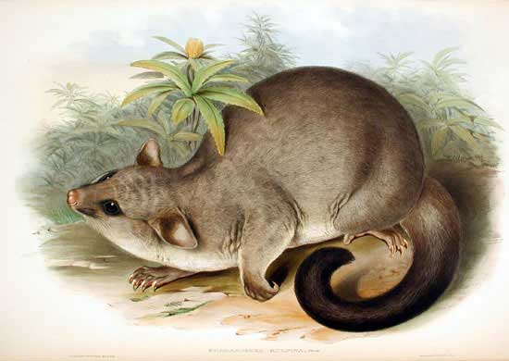

Figure 1. Real photo of a reservoir computing chip based on 7-methyulquinolinium iodobismuthate (left) and an image depicting *Trichosurus Vulpecula* (right).

**Acknowledgment**

The authors acknowledge the financial support from the Polish National Science Centre within the OPUS programme (grant agreement no. UMO-2020/37/B/ST5/00663) and AGH University of Science and Technology within the program “Excellence Initiative-Research University”.