# MicroMAX – Advanced Beamline for Serial Crystallography and Time-Resolved Studies

## M. Bjelčić1, D. Lang1, O. Aurelius1, M. Milas1, M. Chenchiliyan1, C.M. Casadei1, J. Nan1, I. Gorgisyan2, A. E. Jagudin1, M. Eguiraun1, A. Nardella1, A. Gonzalez1, M. Malmgren1, E. Panepucci1, and T. Ursby1

### 1MAX IV Laboratory, Lund University, Fotongatan 2, 224 84 Lund, Sweden, 2European Spallation Source, Partikelgatan 2, 224 84 Lund, Sweden

### Email of communicating monika.bjelcic@maxiv.lu.se

Since its inception in 2016, the BioMAX beamline [1] has been the only beamline for macromolecular crystallography at the MAX IV Laboratory, a fourth-generation synchrotron located in Lund, Sweden. BioMAX has been instrumental in supporting various research endeavours, extending its capabilities to encompass serial crystallography investigations conducted at ambient temperature [2]. These studies have predominantly involved continuous data acquisition using fixed-targets [3] and injectors, alongside pump-probe techniques for capturing time-resolved data [4]. To complement BioMAX and extend the capabilities in serial and room temperature crystallography at the MAX IV Laboratory, the new MicroMAX [5] beamline has been built with funding from the Novo Nordisk Foundation. The experimental features encompass fast scanning stages tailored for fixed-target serial crystallography, an adjustable head for flow experiments, beam sizes down to the single-micron scale, an X-ray chopper to facilitate high flux beam and nano-second laser together with a flexible diode-based pump-probe setup. The beamline offers a flexible sample environment for bespoke experimental setups and also supports high-throughput single-crystal data collections, schematic depiction illustrating the essential components of the experimental configuration is presented in Fig. 1.

MicroMAX recently started user operations and has performed experiments with SPINE-based fixed targets, flow injectors (high viscosity extrusion, capillary), and customized microfluidics mounted to an MD3-up diffractometer. Time-resolved SSX measurements have also been performed using a nanosecond pump laser (210-2600 nm), including cryo-trapping and pump-probe experiments. Eiger2 X 9M CdTe photon counting hybrid pixel detector and Jungfrau 9M Si integrating hybrid pixel detector can be used, with automatic changes between both detectors in under a minute. The end station is also equipped with an automatic sample changer (ISARA2) that can be used in cryogenic conditions housing up to 29 unipucks but can also exchange crystallisation plates and room-temperature spine-based sample holders. Experiments are controlled by MXCuBE with ISPyB and automated pipeline analysis in CrystFEL with live indexing.

The second experimental hutch at MicroMAX can be used for other activities while the first hutch is in X-ray operation. The second hutch is currently used as an off-line laser and spectroscopy laboratory for sample pre-characterization studies, but will also be used to support fully-customized user setups on a breadboard optical table.

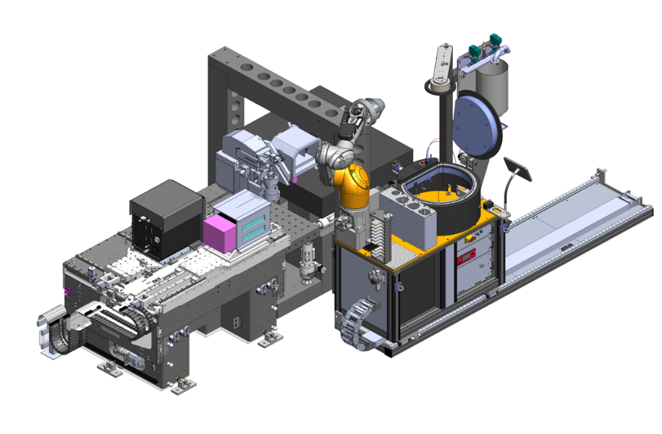

**Arinax MD3-UP microdiffractometer**

**IRELEC ISARA sample changer**

**DECTRIS EIGER2 X CdTe 9M detector**

**Gantry for auxiliary equipment**

**Beam conditioning unit**

**( X-ray chopper)**

**PSI JUNGFRAU 4M**

**(Si) detector**

###### **Figure 1**. CAD representation of a selection of key components of the MicroMAX endstation 1.

[1] Ursby, T., Åhnberg, K., Appio, R., Aurelius, O., Barczyk, A., Bartalesi, A., Bjelčić, M., Bolmsten, F., Cerenius, Y., Doak, R. B., Eguiraun, M., Eriksson, T., Friel, R. J., Gorgisyan, I., Gross, A., Haghighat, V., Hennies, F., Jagudin, E., Norsk Jensen, B., Jeppsson, T., Kloos, M., Lidon-Simon, J., de Lima, G. M. A., Lizatovic, R., Lundin, M., Milan-Otero, A., Milas, M., Nan, J., Nardella, A., Rosborg, A., Shilova, A., Shoeman, R. L., Siewert, F., Sondhauss, P., Talibov, V. O., Tarawneh, H., Thånell, J., Thunnissen, M., Unge, J., Ward, C., Gonzalez, A. & Mueller, U. (2020). J. Synchrotron Rad., 27, 1415.

[2] Shilova, A., Lebrette, H., Aurelius, O., Nan, J., Welin, M., Kovacic, R., Ghosh, S., Safari, C., Friel, R. J., Milas, M., Matej, Z., Högbom, M., Brändén, G., Kloos, M., Shoeman, R. L., Doak, B., Ursby, T., Håkansson, M., Logan, D. T. & Mueller U. (2020). J. Synchrotron Rad., 27, 1095.

[3] Bjelčić, M., Sigfridsson Clauss, KGV., Aurelius, O., Milas, M., Nan, J. & Ursby, T. (2023). Acta Cryst., D79, 1018

[4] Ghosh, S. , Zorić, D. , Dahl, P. , Bjelčić, M. , Johannesson, J. , Sandelin, E. , Borjesson, P. , Björling, A. , Banacore, A. , Edlund, P. , Aurelius, O. , Milas, M. , Nan, J. , Shilova, A. , Gonzalez, A. , Mueller, U. , Brändén, G. & Neutze, R. (2023). J. Appl. Cryst., 56, 449

[5] Gonzalez, A., Krojer, T., Nan, J., Bjelcic, M., Aggarwal, S., Gorgisyan, I., Milas, M., Eguiraun, M., Casadei, C., Chenchiliyan, M., Jurgilaitis, A., Kroon, D., Ahn, B., Ekstrom, J. C., Aurelius, O., Lang, D., Ursby, T. & Thunnissen, M. M. G. M. (2025). J. Synchrotron Rad. 32.