# Predicting crystal form stability under real-world conditions

## D. Firaha1

### 1Avant-garde Materials Simulation, Alte Str. 2, 79249 Merzhausen, Germany

### dzmitry.firaha@avmatsim.eu

Understanding and predicting the relative stability of crystalline forms under real-world conditions is one of the challenges in materials design and pharmaceutical development. A computational method called TRHu(ST) 23 is presented that goes beyond traditional “zero Kelvin” lattice energy rankings by explicitly considering temperature and relative humidity[1], two key environmental factors influencing the stability of the hydrate and anhydrates crystal forms of organic compounds. Our approach captures the interplay between enthalpy and entropy contributions, offering insights into solid-state phase transitions as a function of temperature and relative humidity, which are missed in standard 0 K simulations.

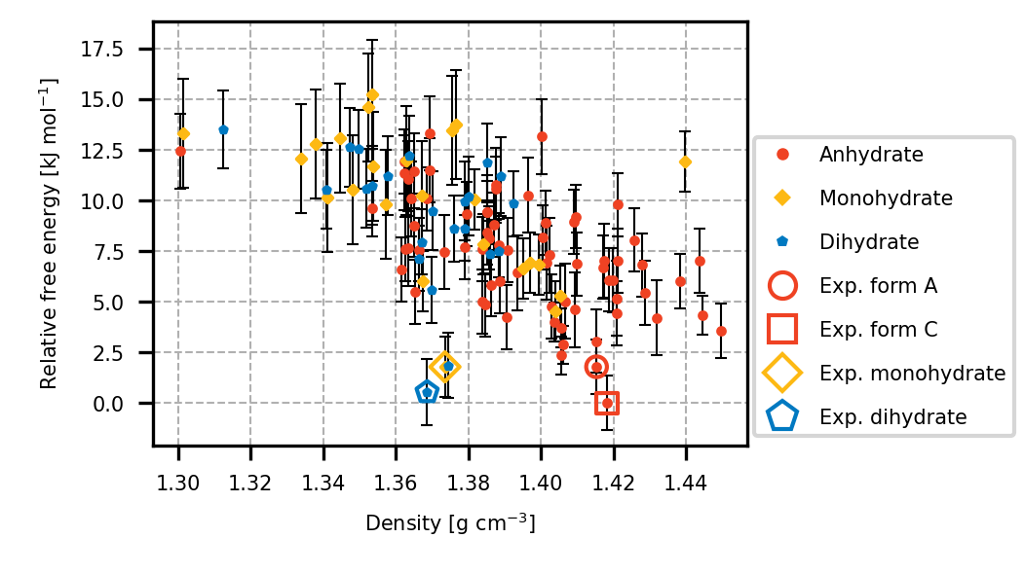

###### **Figure 1**. Free-energy landscape of radiprodil hydrate and anhydrate forms at 298.15 K and a relative humidity of 50%.

We demonstrate the effectiveness of this method against a benchmark of molecular crystals with known temperature-dependent polymorphism and sensitivity to water in the air (Fig. 1). Our predictions align closely with experimental stability data, phase-transition temperatures and phase-transition relative humidities, highlighting the usefulness of these calculations to guide experimental screening and drug-formulation strategies. By bridging the gap between idealized simulations and practical conditions, this work sets the stage for more reliable *in silico* design of materials with desired solid-state properties.

The excellent performance of various precursors of the TRHu(ST) 23 method in the 2024 crystal structure prediction blind test will be discussed will be discussed and provides further evidence for the general applicability of the approach [2,3].

#### [1] Firaha, D. *et al*. (2023). *Nature* **623**, 324.

#### [2] Hunnisett, L. *et al*. (2024). *Acta Cryst*. B**80**, 517.

#### [3] Hunnisett, L. *et al*. (2024). *Acta Cryst*. B**80**, 548.

All authors of reference [1] are gratefully acknowledged for having made this work possible.