# High-throughput fixed target SFX for pharmaceutical screening at the European XFEL

## P. Smyth1, K. Dörner1, H. Han1, S. Günther2, J. Bielecki1, R. Letrun1, D. Zabelskii1, D. Melo1, R. de Wijn1, Y. Kim1, K. Kharitonov1, F. Koua1, P. Reinke2, S. Falke2, S. Thekku Veedu2, J. Glerup3, G. Wehlander3, R. Schubert1, J. Schulz1, A. Meents2

### 1European XFEL GmbH, Holzkoppel 4, 22869 Schenefeld, Germany, 2Center for Free-Electron Laser Science, Deutsches Elektronen-Synchrotron DESY, Notkestraße 85, 22607 Hamburg, Germany, 3University of Gothenburg, Universitetsplatsen 1, Göteborg, Sweden

### peter.smyth@xfel.eu

Protein structures collected at room temperature are important when conducting drug design studies, since protein-ligand binding is temperature dependent, and room temperature data more accurately predicts interactions under physiological conditions [1]. Efficient sample delivery has remained a challenge for serial femtosecond crystallography, and commonly used methods require large amounts of sample and beamtime. Fixed target sample delivery with the Roadrunner goniometer is ideally suited to X-ray drug discovery where throughput is important, as complete datasets can be collected under 30 minutes [2, 3].

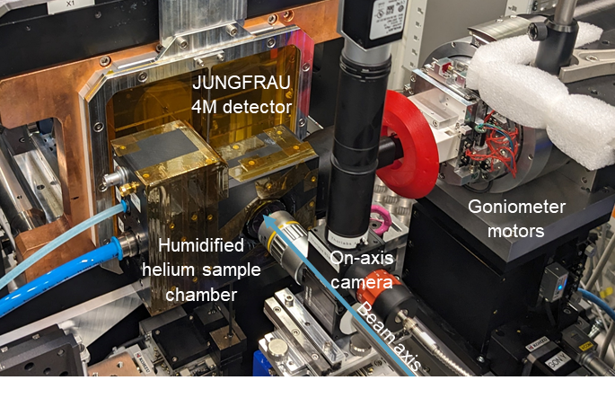

###### **Figure 1.** The Roadrunner goniometer at the downstream interaction region of the SPB/SFX instrument ad the European XFEL.

The goniometer has already been successfully commissioned at the SPB/SFX instrument at the European XFEL (Fig. 1). We are using this technique to investigate compound and fragment binding to potential drug targets, with UDP-N-acetylglucosamine enolpyruvyl transferase (MurA) as an initial goal [4, 5].

#### [1] Ebrahim, A., Riley, B. T., Kumaran, D., Andi, B., Fuchs, M. R., McSweeney, S., & Keedy, D. A. (2022). *IUCrJ*, **9**, 682–694.

#### [2] Roedig, P., Vartiainen, I., Duman, R., Panneerselvam, S., Stübe, N., Lorbeer, O., Warmer, M., Sutton, G., Stuart, D. I., Weckert, E., David, C., Wagner, A., & Meents, A. (2015). *Sci. Rep.*, **5**, 10451.

[3] Shelby, M. L., Gilbile, D., Grant, T. D., Seuring, C., Segelke, B. W., He, W., Evans, A. C., Pakendorf, T., Fischer, P., Hunter, M. S., Batyuk, A., Barthelmess, M., Meents, A., Coleman, M. A., Kuhl, T. L., & Frank, M. (2020). *IUCrJ*, **7**, 30–41.

#### [4] de Oliveira, M. V. D., Furtado, R. M., da Costa, K. S., Vakal, S., & Lima, A. H. (2022). *Front. Mol. Biosci.*, **9**.

#### [5] Zhu, J.-Y., Yang, Y., Han, H., Betzi, S., Olesen, S. H., Marsilio, F., & Schönbrunn, E. (2012). *J. Biol. Chem.*, **287**, 12657–12667.

The project on which this report is based was funded by the German Federal Ministry of Education and Research under grant number 13K22XXA. The responsibility for the content of this publication lies with the author.