GruPol: A Database-Driven Framework for Predicting Biomolecular Electrostatic and Optoelectronic Properties

A. Krawczuk¹, R. F. Ligorio¹

¹Institue of Inorganic Chemistry, University of Goettingen, Tammanstrasse 4, 37077 Goettingen, Germany

anna.krawczuk@uni-goettingen.de
The GruPol database is a computational tool developed to predict electrostatic and optoelectronic properties of biomolecules by exploiting the transferability of polarizability tensors derived from quantum chemical calculations.[1] Built using the distributed polarizabilities approach implemented in the PolaBer software,[2] GruPol assigns polarizability tensors to functional groups, enabling efficient construction of full-molecule properties from transferable components.
In this contribution, we focus on demonstrating the capabilities of GruPol in modelling various responsive properties relevant for accurate modelling of biomolecules (Fig.1). Specifically, we will present its performance in reproducing dipole moments, electrostatic potentials (ESP), and polarizabilities of peptides and proteins under varying conditions such as pH changes, solvation effects, and ionic environments.[3,4]. Present case studies will include various well-known proteins, such as insulin or myoglobin, where the GruPol-based predictions align well with full quantum mechanical references. Our results show that the database-based approach can effectively capture subtle changes in electrostatic properties caused by protonation states or ionic surroundings, emphasizing its utility for fast yet accurate screening of complex biomolecular systems.

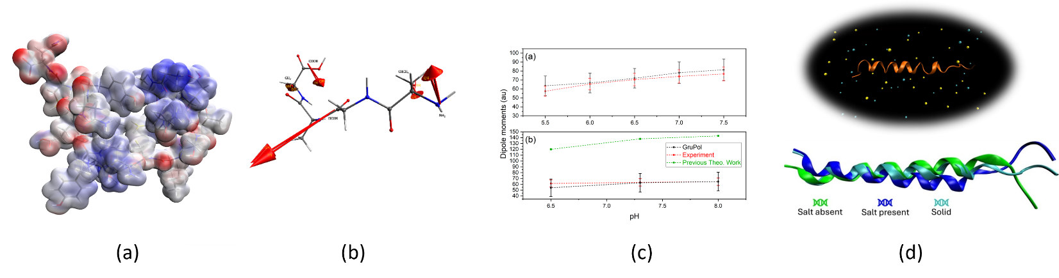
Figure 1 Functionalities of GruPol database: (a) electrostatic potential prediction, (b) dipole moment estimation, (c) pH dependence, and (d) salt effects modelling.

[1] Ligorio, R.F., Grosskopf, P., Dos Santos, L.H.R. & Krawczuk, A. (2024) J. Phys. Chem. B, 128, 7954.

[2] Krawczuk, A., Perez, D. & Macchi, P. (2015) J. Appl. Cryst. 47, 1452.

[3] Ligorio, R.F., Rodrigues, J.L., Zuev, A., Dos Santos, L.H.R. & Krawczuk, A. (2022) Phys. Chem. Chem. Phys. 24, 29495.

[4] Ligorio, R.F., Gehle, R.H.M., Dos Santos, L.H.R. & Krawczuk, A. (2025) Acta Cryst. B, 81, 192.

