# Local structure of Ammonia Borane described using PDF method

## A. Piekara1, W. Sławiński1

### 1Faculty of Chemistry, University of Warsaw, Pasteura 1, 02-093 Warszawa

### ak.piekara@uw.edu.pl

Ammonia Borane BH3NH3 is a compound of high interest because of its potential use as a hydrogen storage medium [1,2]. The room temperature phase is described by a tetragonal space group I4mm (Z = 2, a = b = 5.263 Å, c = 5.050 Å) [1,2]. For decades, the room-temperature phase of Ammonia Borane has been a topic of discussion due to the occurrence of disordered hydrogen in this phase.

The disorder arises from the conflict between the molecule (point group) and crystallographic (3D) symmetries. The B-N bond is aligned with a 4-fold rotation axis, which is incompatible with the -BH3 and -NH3 groups symmetry [1]. As a result, the crystal of Ammonia Borane is highly plastic. To describe the local structure and, notably, to identify the positions of hydrogen, we conducted synchrotron X-ray measurements utilising the total scattering method to perform the Pair Distribution Function (PDF) analysis.

To analyse the local structure, we combine x-ray based PDF method with Reverse Monte Carlo (RMC) using the RMCProfile7 [3] program (**Figure 1)**. The RMCProfile7 refinement allows a better understanding of the average crystal structure and refines it against Bragg diffraction data, but at the same time to satisfy local atom/molecule arrangements. This local atom and molecule short-range order can be modelled by the refinement against Pair Distribution Function G(r) and D(r) (see Fig. 1 a) and structure factor F(Q) and QF(Q).

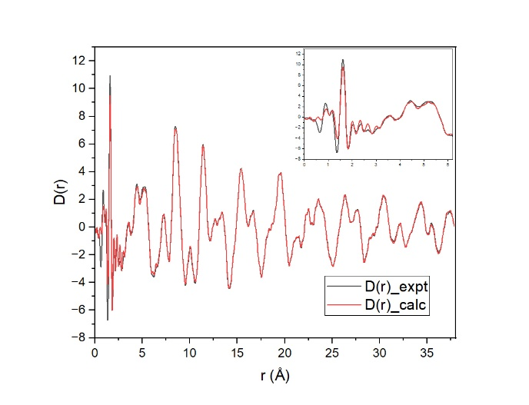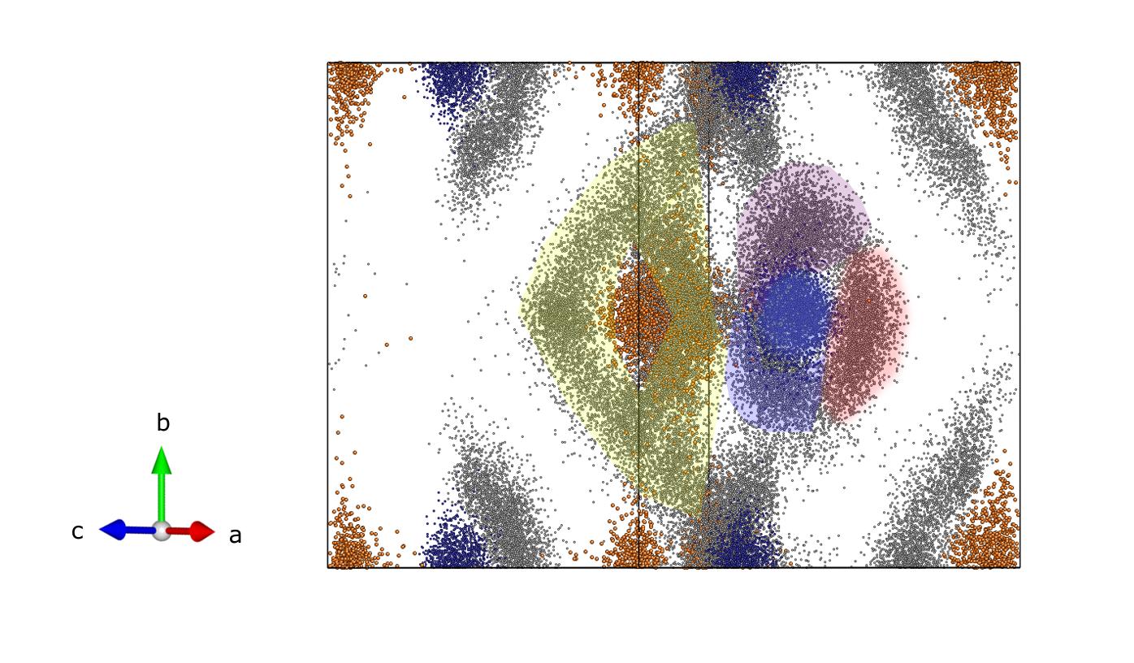

**a)**

**b)**

###### **Figure 1**. PDF obtained from the experiment (black) and one from RMC calculation a) and distribution of atoms after the RMC refinement b) (N in red, B in blue and H clouds around N and B).

The calculation demonstrates that big box configurations show structural disorder, which agrees well with the average crystal structure, but at the same time shows how individual molecules are oriented in space and also how does individual molecules look like. Our simulations align well with the experimental data, even in the area of short interatomic distances (B-H, N-H and B-N bond distances), which is quite unique for PDF analysis. The results suggest that, despite significant hydrogen disorder, it is still possible to identify local molecule symmetry and specific positions where hydrogen atoms are likely to be located (see Fig. 1 b)

#### [1] Demirci, U. B. (2017), Ammonia borane, a material with exceptional properties for chemical hydrogen storage, International Journal of Hydrogen Energy.

#### [2] Bowden, M. E., Gainsford, G. J., Robinsonb, W. T., Robinsonb (2007), Room-Temperature Structure of Ammonia Borane, Australian Journal of Chemistry.

#### [3] Sławiński, W. A., Kerr, C. J., Zhang, Y., Playford, H. Y., Dove, M. T., Phillips, A. E. & Tucker, M. G. (2024). RMCProfile7: reverse Monte Carlo for multiphase systems. J. Appl. Cryst.