The potential of microwaves and mechanochemistry in obtaining novel multicomponent forms of theophylline with benzene-1,2,4,5-tetracarboxylic acid as a coformer

M. Gołdyn^{1,2}, E. Bartoszak-Adamska², W. Nowak², O. Grupa²

¹ Center for Advanced Technologies, Adam Mickiewicz University, Uniwersytetu Poznańskiego 10, 61-614 Poznań, Poland,
²Faculty of Chemistry, Adam Mickiewicz University, Uniwersytetu Poznańskiego 8, 61-614 Poznań, Poland

elzbieta.bartoszak-adamska@amu.edu.pl
Cocrystals are multicomponent crystalline materials composed of two or more neutral molecules in a defined stoichiometric ratio, stabilized by non-covalent interactions [1]. They are widely explored in pharmaceutical solid-state engineering to modulate the physicochemical properties of active pharmaceutical ingredients (APIs), such as solubility, stability, and thermal behavior, without altering their pharmacological activity [2].
The presented study focuses on the theophylline – benzene-1,2,4,5-tetracarboxylic acid (TPH – PMLA) system, in which four distinct crystalline forms were identified: two polymorphic 2:1 cocrystals (TPH·PMLA I and II, Fig. 1), and two cocrystal solvates incorporating water (TPH·PMLA·H₂O 1:1:2) and methanol (TPH·PMLA·MeOH 2:1:2). These multi-component systems were obtained selectively by neat or liquid-assisted grinding and microwave-assisted slurry cocrystallization [3]. These techniques enable rapid, efficient, and solvent-minimizing preparation of cocrystals. Additionally, adjusting the method and conditions
of cocrystallization allows for the control of obtaining a specific crystal form. Novel phases formation was confirmed using powder
X-ray diffraction. The obtained solids were also structurally characterized by single-crystal X-ray diffraction, revealing diverse supramolecular synthons responsible for the molecular arrangement in the crystal lattice. UV-Vis spectroscopy studies demonstrated that cocrystallization with PMLA could change the aqueous solubility of theophylline, depending on the crystal form. Simultaneous thermal analysis revealed differences in thermal stability among the cocrystals. In turn, variable-temperature single-crystal X-ray diffraction performed for TPH·PMLA·MeOH adduct revealed negative volumetric thermal expansion and a temperature-induced phase transition of the methanol solvate into cocrystal form [3].
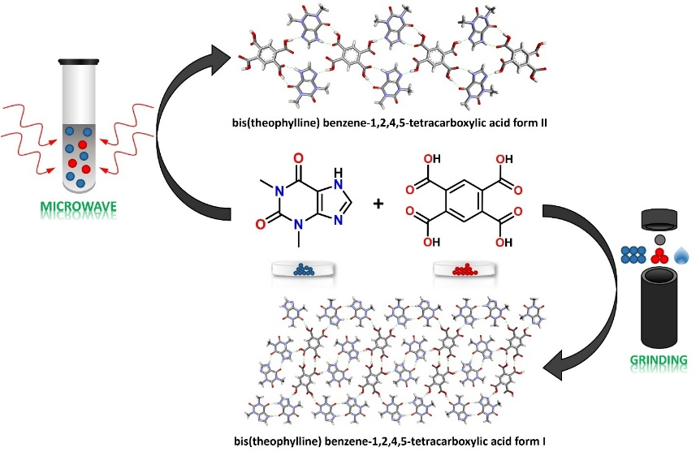

Figure 1. The influence of the cocrystallization technique on the selectivity in obtaining polymorphic forms (I and II) of TPH·PMLA 2:1 cocrystals.
These findings contribute to the understanding of supramolecular interactions governing cocrystal formation and stability and underline the importance of cocrystallization in tailoring API properties. The work reinforces the value of green synthetic approaches in developing pharmaceutical solid forms.

[1] Grothe E., Meekes H., Vlieg E., J. H. ter Horst & R. de Gelder (2016). Cryst Growth Des. 16, 3237.

[2] Karagianni A., Malamatri M. & Kachrimanis K. (2018). Pharmaceutics, 10, 18.

[3] Nowak W., Gołdyn M., Grupa O., Starzyk J., Larowska-Zarych D., Frąckowiak K. & Bartoszak-Adamska (2025). ACS Sustain Chem Eng, submitted
MG thanks the National Science Centre (grant PRELUDIUM no. 2021/41/N/ST5/00503) for financial support and Adam Mickiewicz University for funds from the Initiative of Excellence – Research University (IDUB) program obtained in the PhD Minigrants competition no. 017 (research grant no. 017/02/SNŚ/0005).

