# Tackling the challenge of unpublished structures

## Gary S. Nichol1

### 1School of Chemistry, The University of Edinburgh, Joseph Black Building, David Brewster Road, Edinburgh, EH9 3FJ, UK

### [g.s.nichol@ed.ac.uk](mailto:g.s.nichol@ed.ac.uk)

It is thought that the published output of a university service crystallography laboratory represents just 15-20% of its total, useful work [1]. What are colleagues doing with their structures?! Unwanted, or unnecessary, solvates are determined. Side-products crystallize better than the compound of interest. Projects sometimes simply fizzle out. Whatever the reason, this leaves, potentially, some 80% of perfectly good, chemically correct and scientifically useful work languishing on hard drives, in filing cabinets and as a forgotten archive folder on an institutional server.

At the same time funding councils push to make data open – publicly available - with different institutions having their own solutions. Whilst this author was cheered to see his own work on the front page of the university’s repository (Fig. 1, [2]) a quick check of different depositions, selected at random, shows that this service is being used to provide further supporting evidence to support published work. There is, in all depositions that this author examined, reference to a publication in the primary literature.

As a technique, as a body of scientists, we in crystallography already have had a solution for many years. The Cambridge Crystallographic Data Centre accepts direct submissions of structural work outwith the mechanism of traditional publication, first as *Private Communications* and then *CSD Communications*. This talk will discuss how in Edinburgh we use *CSD Communications* to support summer project students tasked with identifying, checking, validating and then depositing previous unreported work from our facility archive. It will include an ‘historical’ perspective, dealing with output of a part-time crystal structure service run by one post-doc, and identify future challenges posed by the volume of data produced in the modern, three-diffractometer lab and a hands-on user base of some twenty people.

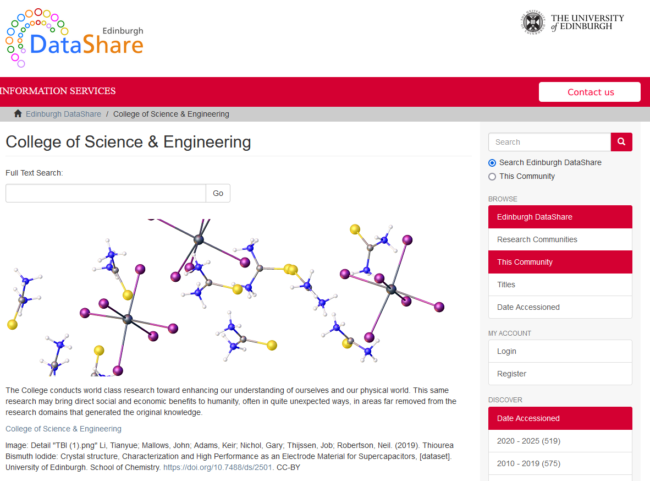

###### **Figure 1**. Edinburgh University’s DataShare service, a repository of publicly-available research data.

#### [1] Coles & Gale, *Chem. Sci*., 2012, **3**, 683-689

#### [2] https://datashare.ed.ac.uk/handle/10283/927, accessed 20/05/25