# Application and challenge on characterization of thin-crystalline organic material structures with electron diffraction

## K. Takaba

*Faculty of Chemistry, University of Vienna, Währinger Straße 42, 1090 Vienna, Austria*

### kiyofumi.takaba@univie.ac.at

There is a growing demand for the structural analysis of organic molecules for semiconductors to elucidate their function in material science. These molecules can crystallize, although they tend to grow in limited dimensions, as they are designed to exhibit anisotropic electroconductivity. The thickness of the crystals can sometimes be around 10 nm or less, corresponding to just a few layers of composed molecules.

Transmission electron microscopy and its diffraction techniques are effective tools for observing such nano-structured materials. Through collaboration with synthetic chemists, the author has explored potential contributions to material science using state-of-the-art techniques in electron microscopy and crystallography [1-4]. Fig. 1 illustrates the resolution in observation with electron beam accelerated at 100 kV and 200 kV, measured with the JUNGFRAU charge-integration detector currently under development for electron diffraction [5, 6]. Although lower energy electrons enhance the real-image contrast as expected [7], higher energy probes still provide advantages in diffraction resolution. In the microsymposium, we will discuss the challenges in obtaining more detailed structural information about thin-crystalline materials, along with the latest updates in our methodology.

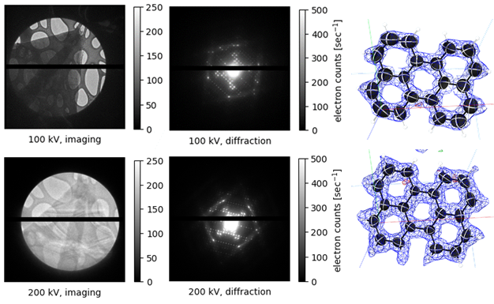

###### **Figure 1**. Imaging and diffraction resolution in transmission electron microscopy with 100 kV and 200 kV electron beams. The sample tested was a thin-crystal of perylene. The measurement was performed using the JEM2100Plus TEM (JEOL) and the JUNGFRAU detector (PSI) at the University of Vienna.

#### [1] Takaba, K., Maki-Yonekura, S., Inoue, S., Hasegawa, T. & Yonekura, K. (2021). *Front. Mol. Biosci.* **7**

[2] Inoue, S. *et al.* (2022). *Chem. Mater.* **34**(1), 72-83. [3] Higashino, T. *et al.* (2024). *Chem. Mater.* **36**(2), 848-859.

[4] Nikaido, K. *et al.* (2024). *Phys. Rev. Mater.* **8**(11), 115601. [5] Frojdh, E. *et al.* (2020). *Crystals* **10**, 1148

[6] Ferjaoui, K., Takaba, K., Frojdh, E., Gruene, T. (2024) https://github.com/epoc-ed

[7] Peet, M. J., Henderson, R. & Russo, C. J. (2019) *Ultramicroscopy* **203**, 125-131.

The author thanks Toshiki Higashino for providing the crystal samples for the measurement.